React:

Open source library for building user interfaces

It is a java script library not framework

It focuses on doing one thing and that one thing really well

Focus on UI (not on http request, routing)

Rich ecosystem (has libraries to handle other things to build full fledged applications)

Why learn React?

Created and maintained by Facebook

React has more than a 100 thousand stars on GitHub and a huge community behind it.

React has become increasingly popular among developers and is also one of the most sought out skill-sets by companies right now.

React has a component-based architecture.

This lets you break down your application into small encapsulated parts which can then be composed to make more complex UI.

React is declarative. Tell react what you want and react will build the actual UI.

React will make it painless for you to create complex UIs by abstracting away the difficult parts.

React will handle efficiently updating and rendering just the right components in your application when your data changes.

DOM updates which is one of the more expensive operations is handled gracefully in React.

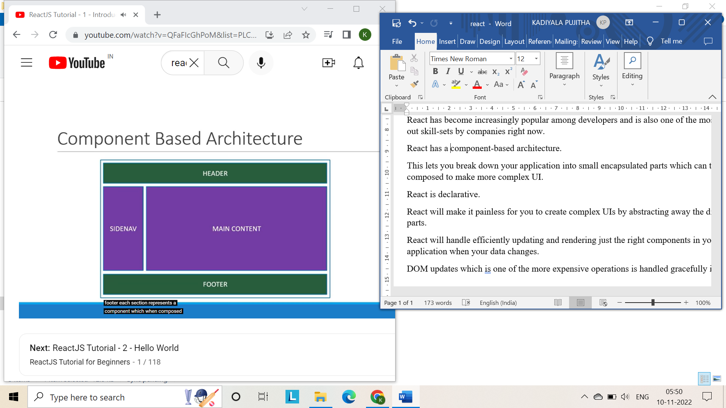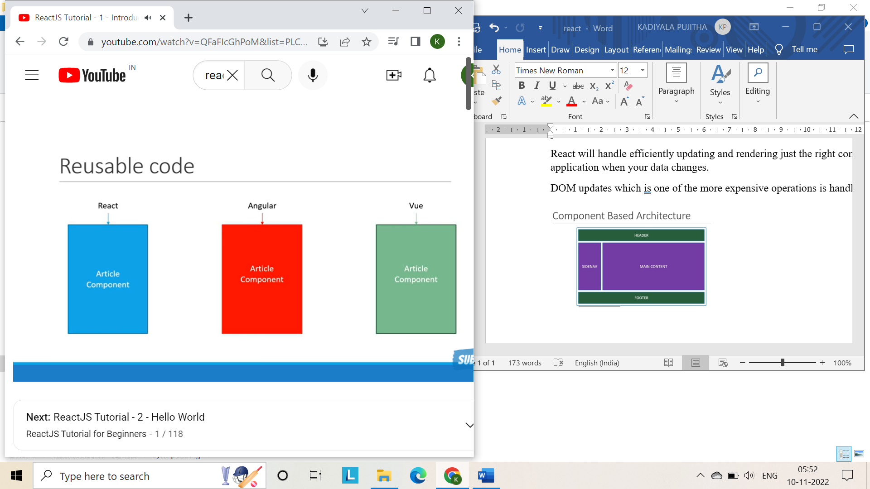

More on why react?

Seamlessly integrate react into any of you application

Portion of your page or a complete page or even an entire application itself.

React native for mobile applications

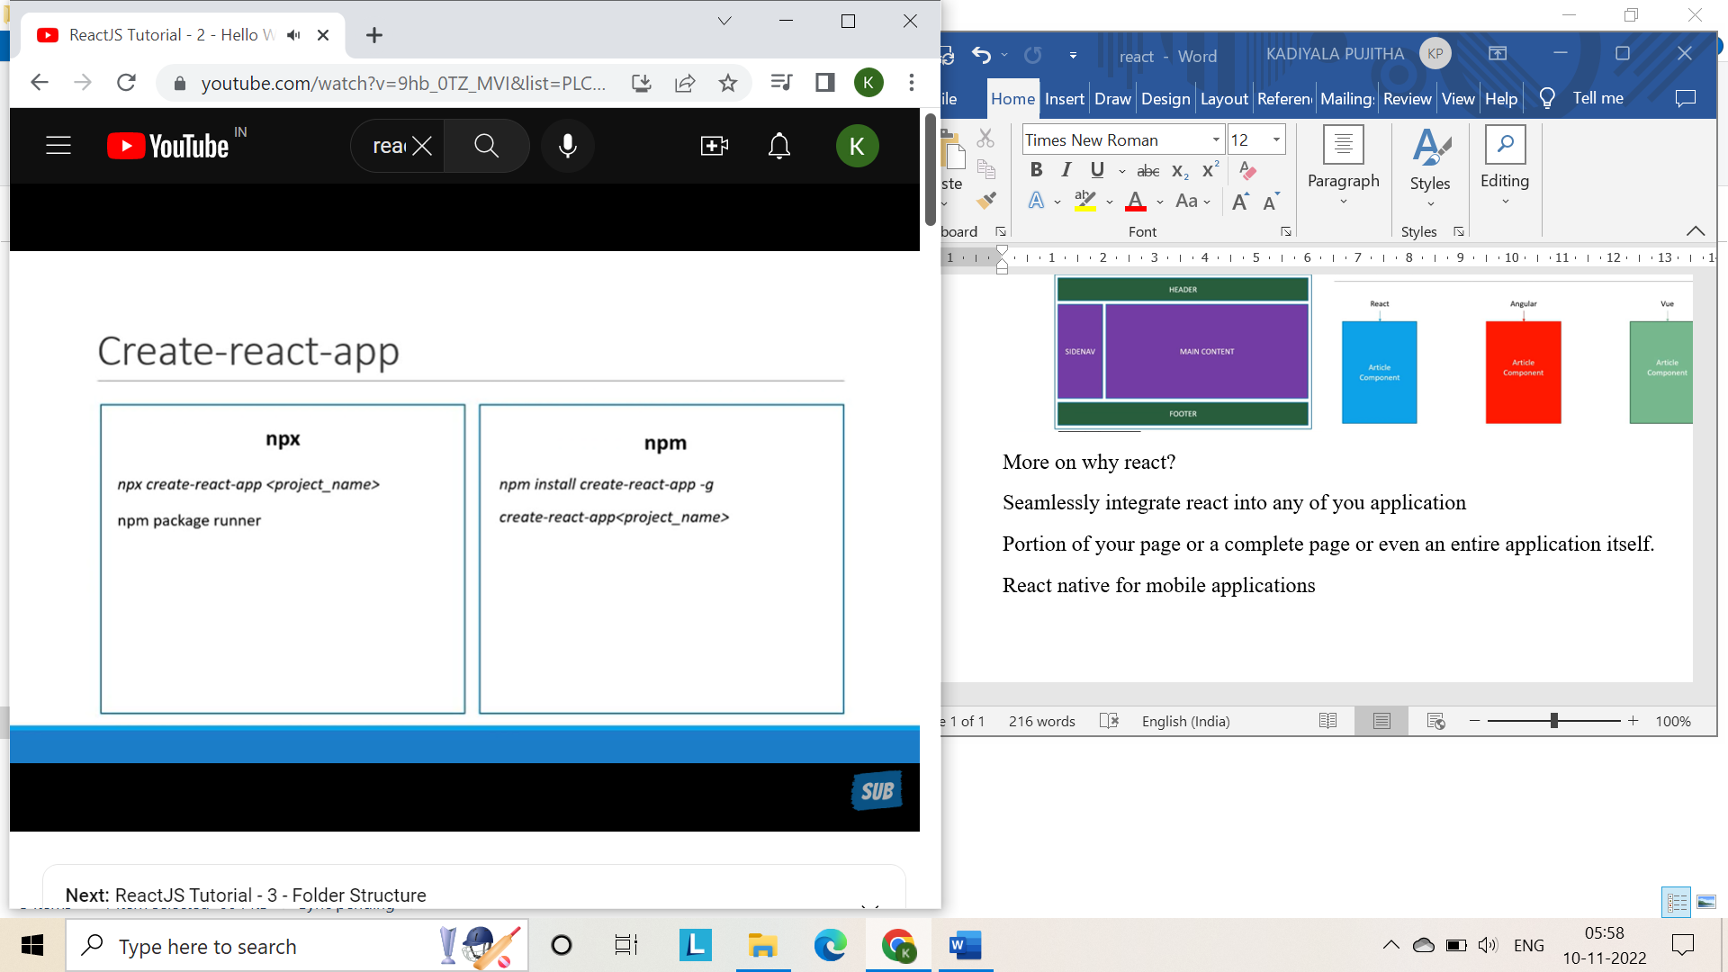

Package.json: this file contains dependencies required for the project.

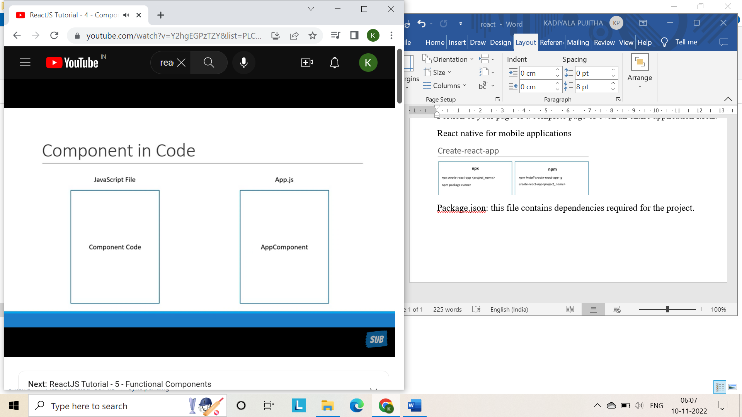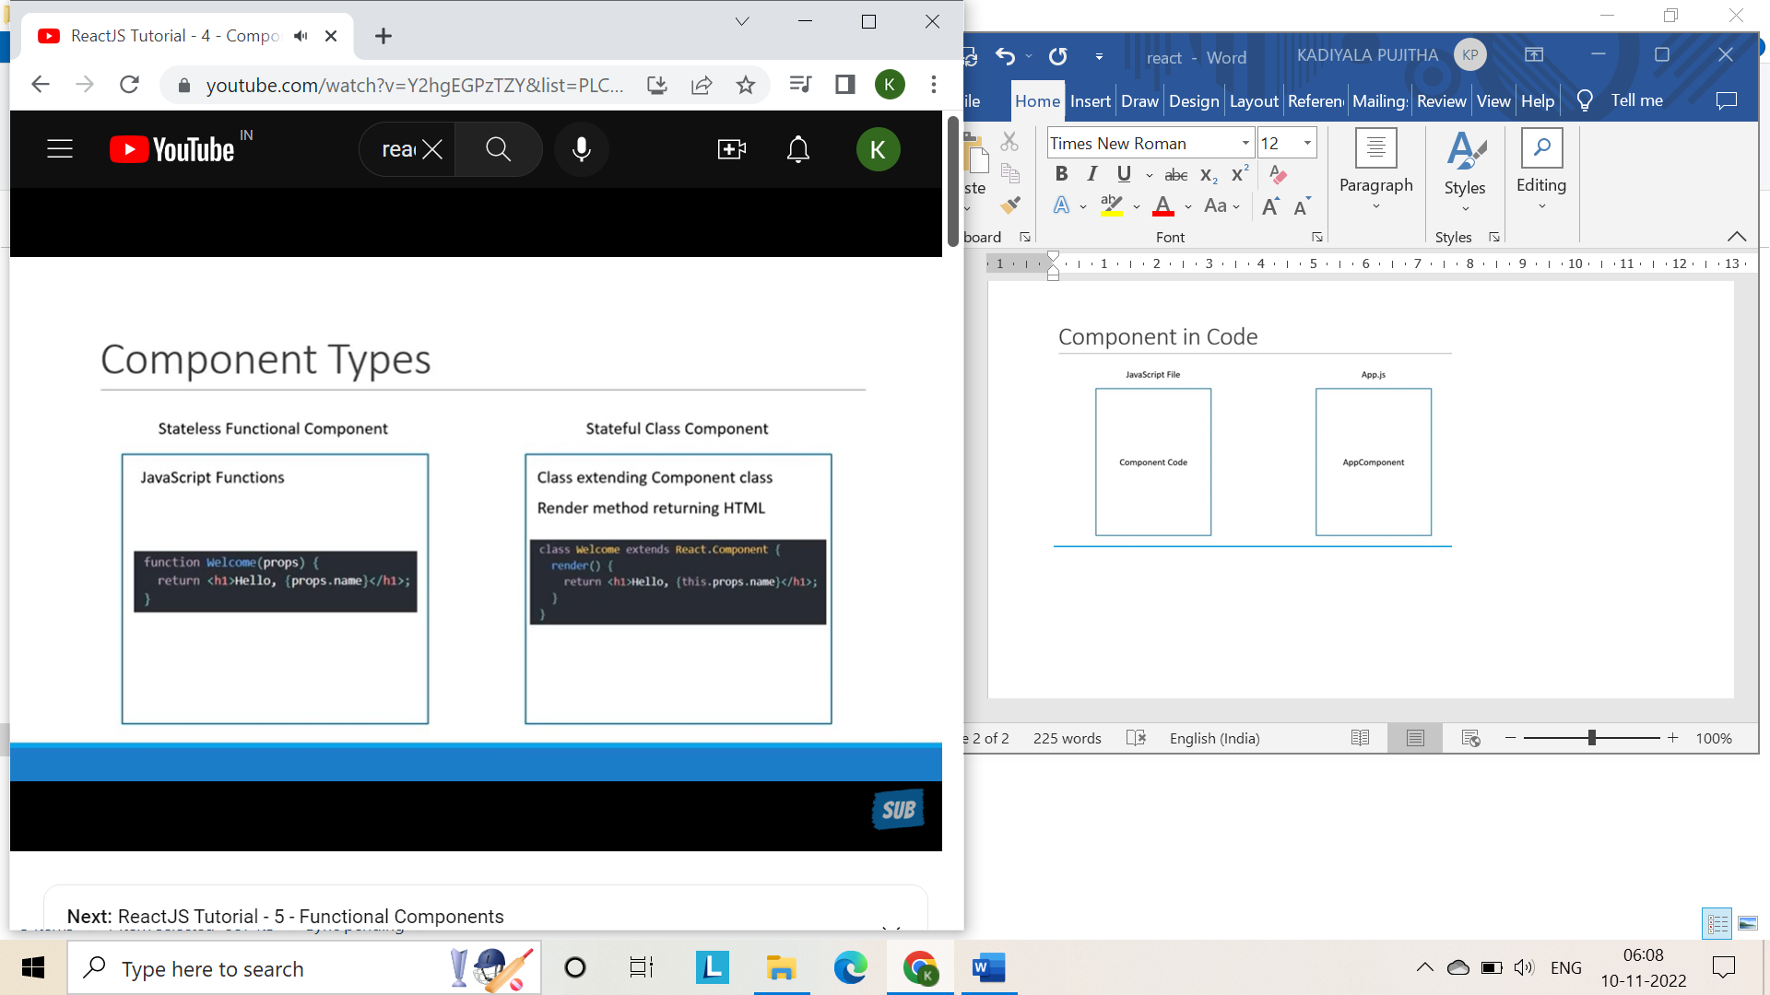

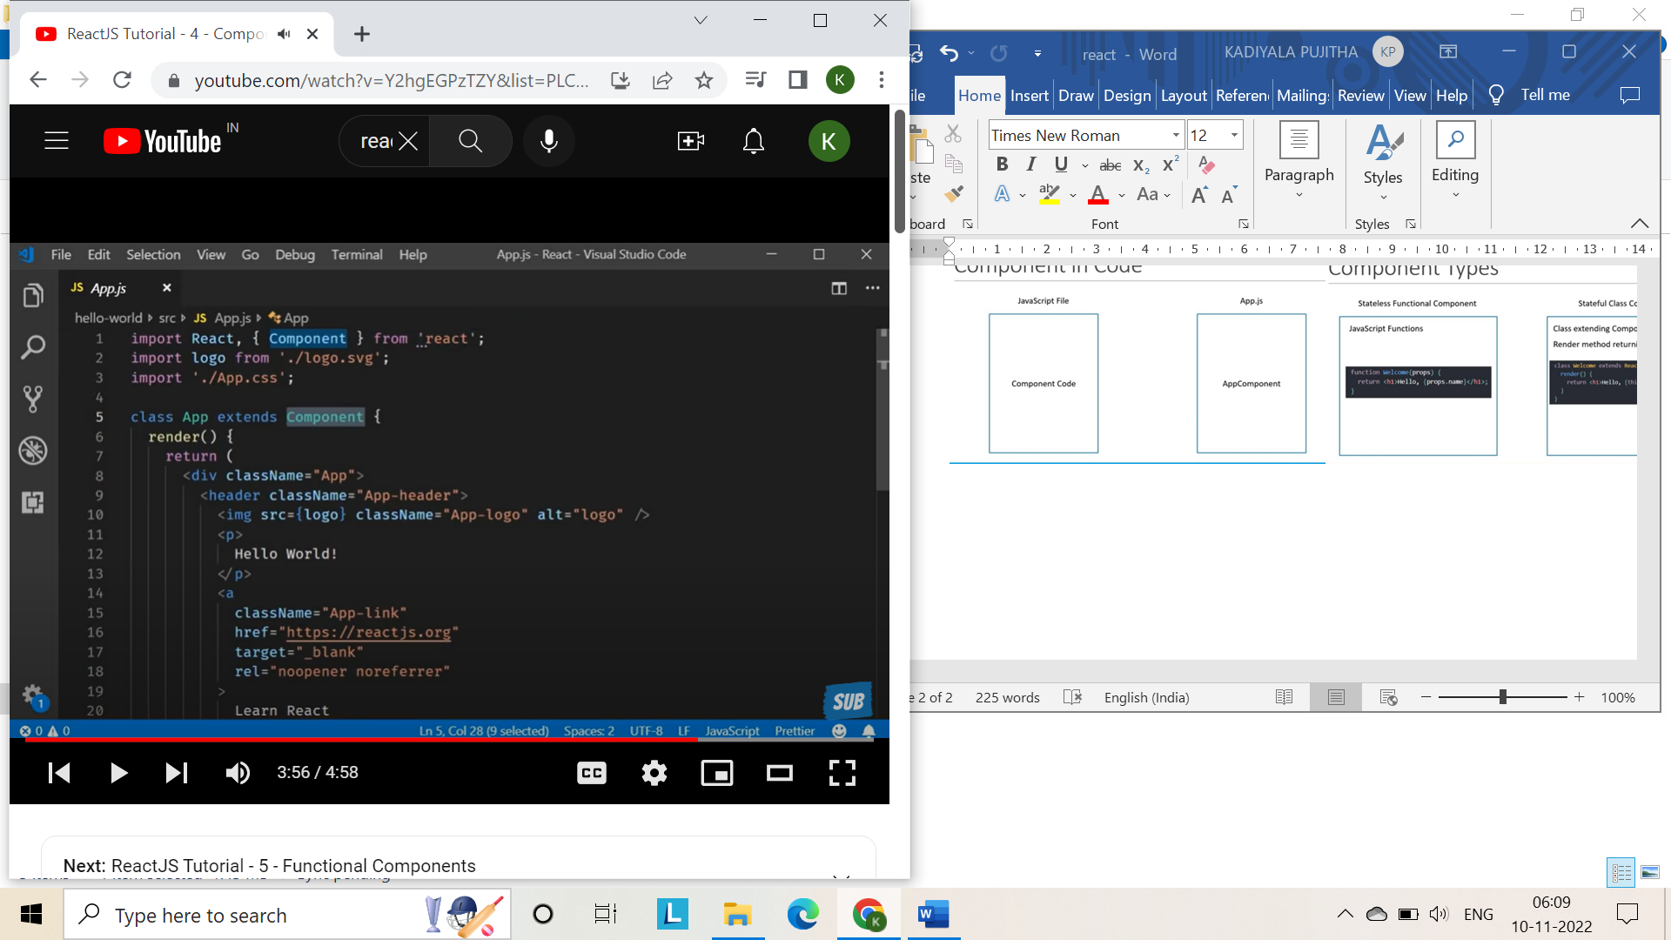

Components:

They describe a part of the user interface

They are re-usable and can be nested inside other components

Two types:

1. Stateless functional components
2. Stateful class components

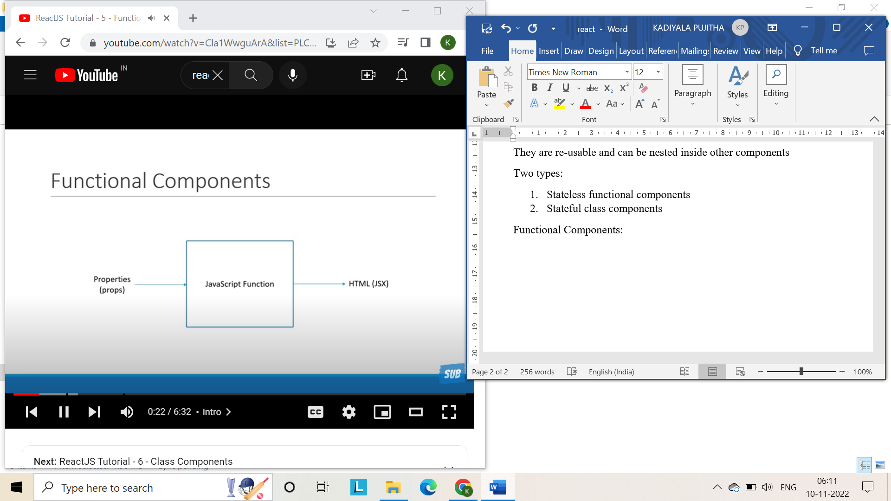

Component: greet.js

Make sure to import react from ‘react’ at the starting

And export greet.js and import it in app.js

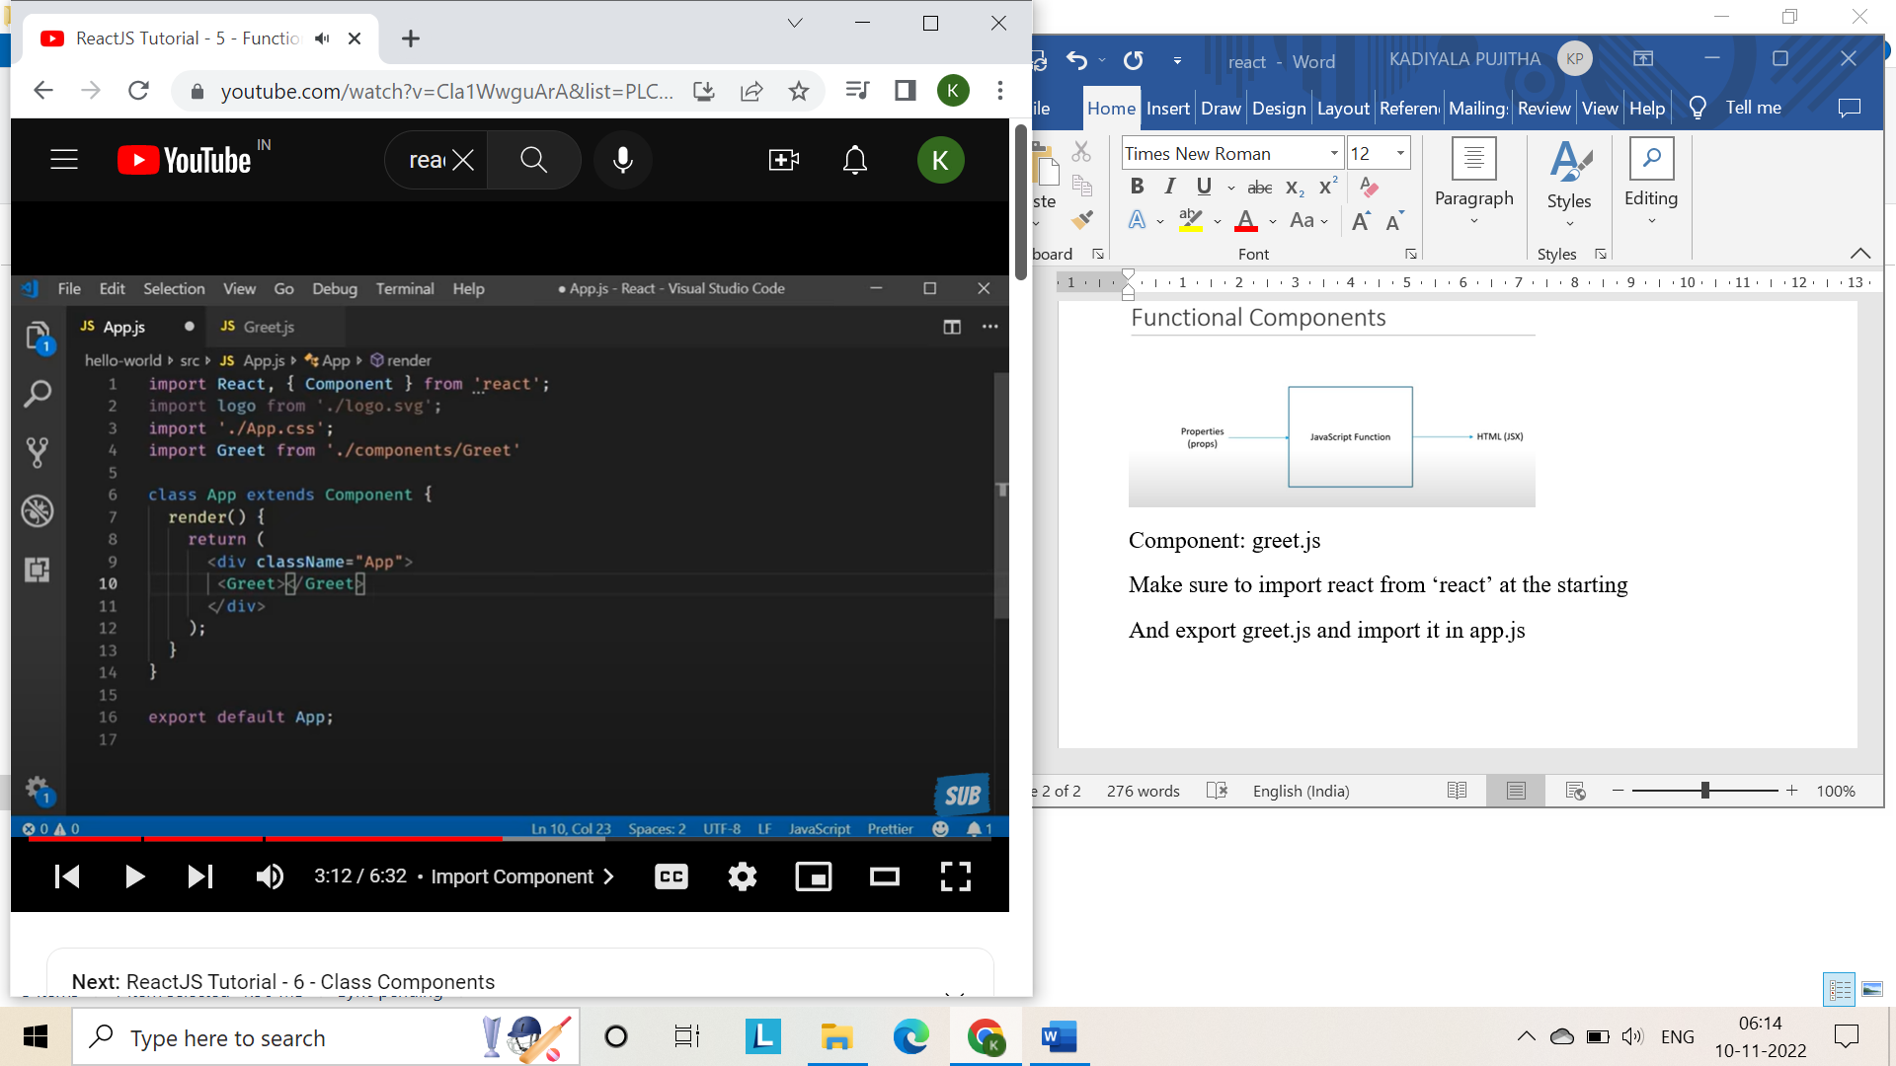

We can use arrow functions also.

const Greet = () =><h1>Hello Pujitha</h1>

export default Greet

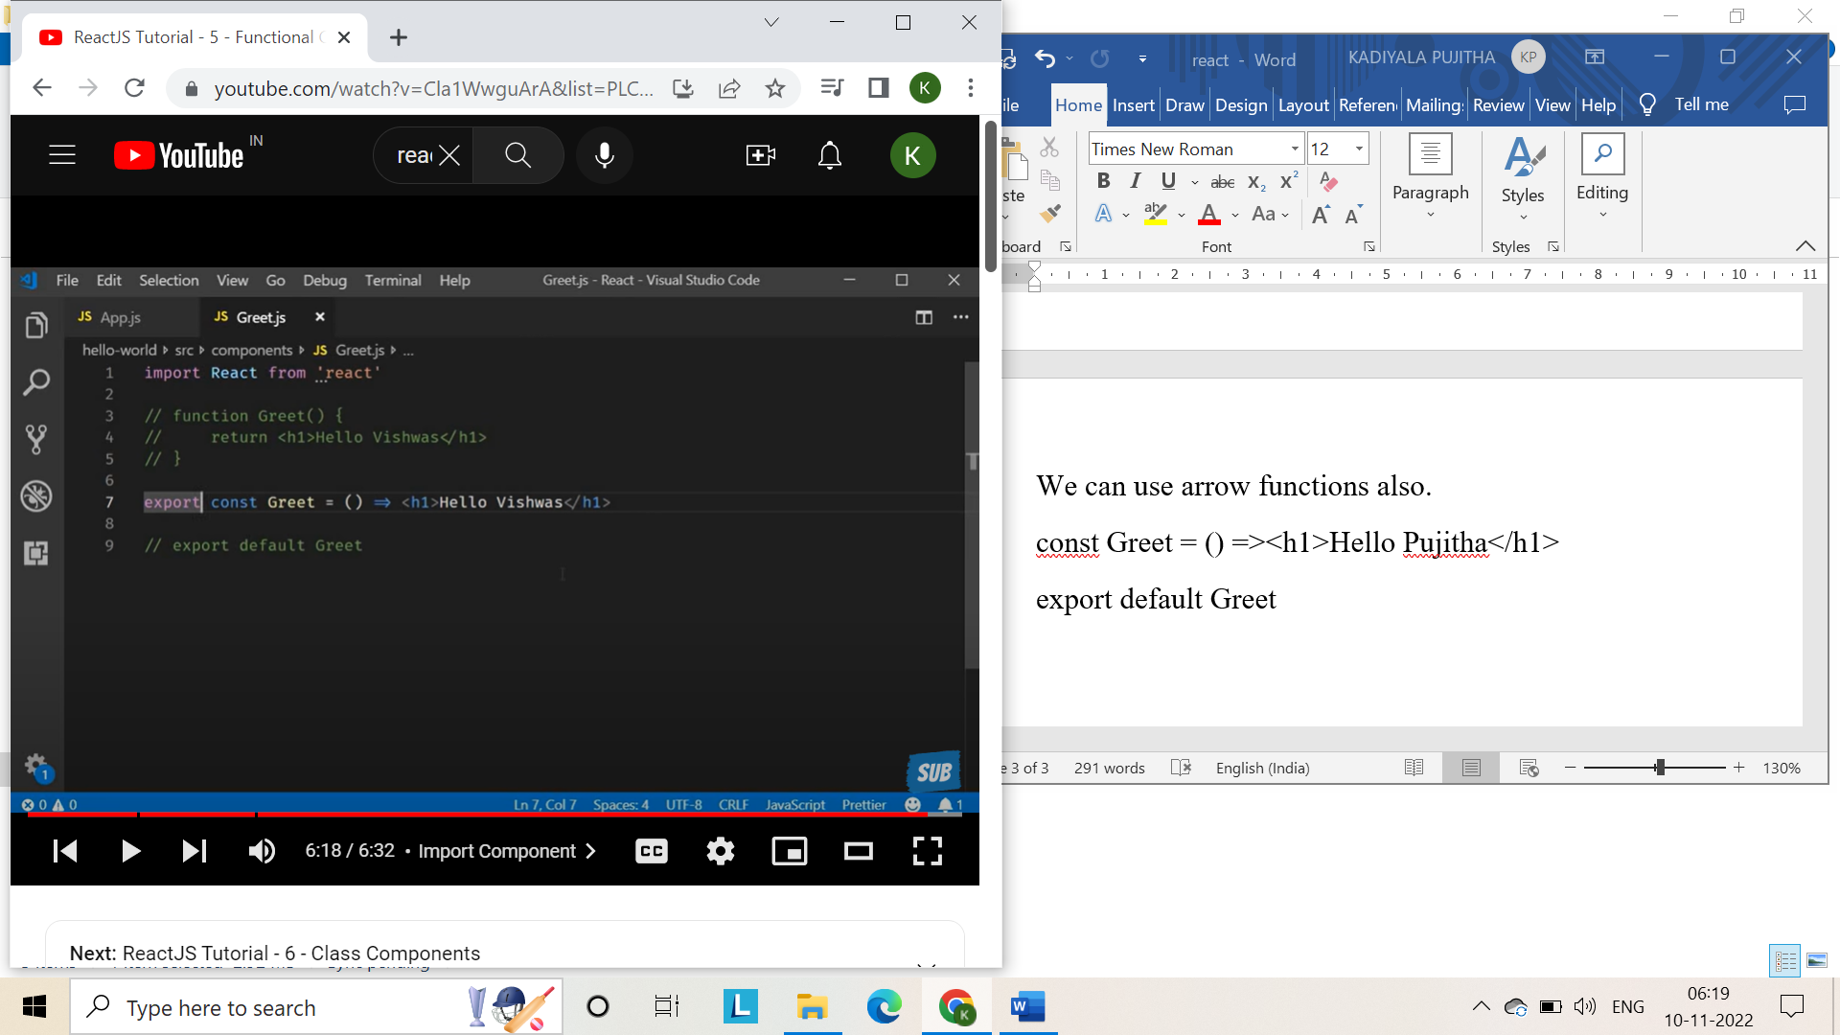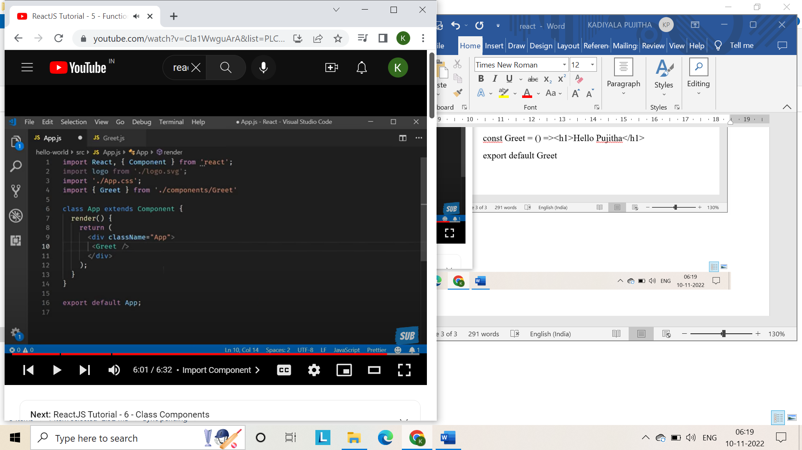

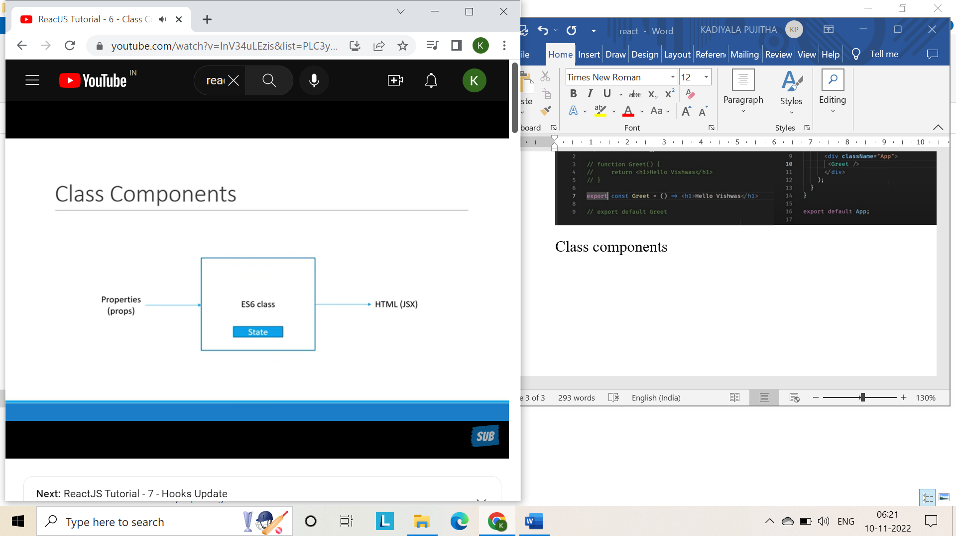it maintains some information private to it.

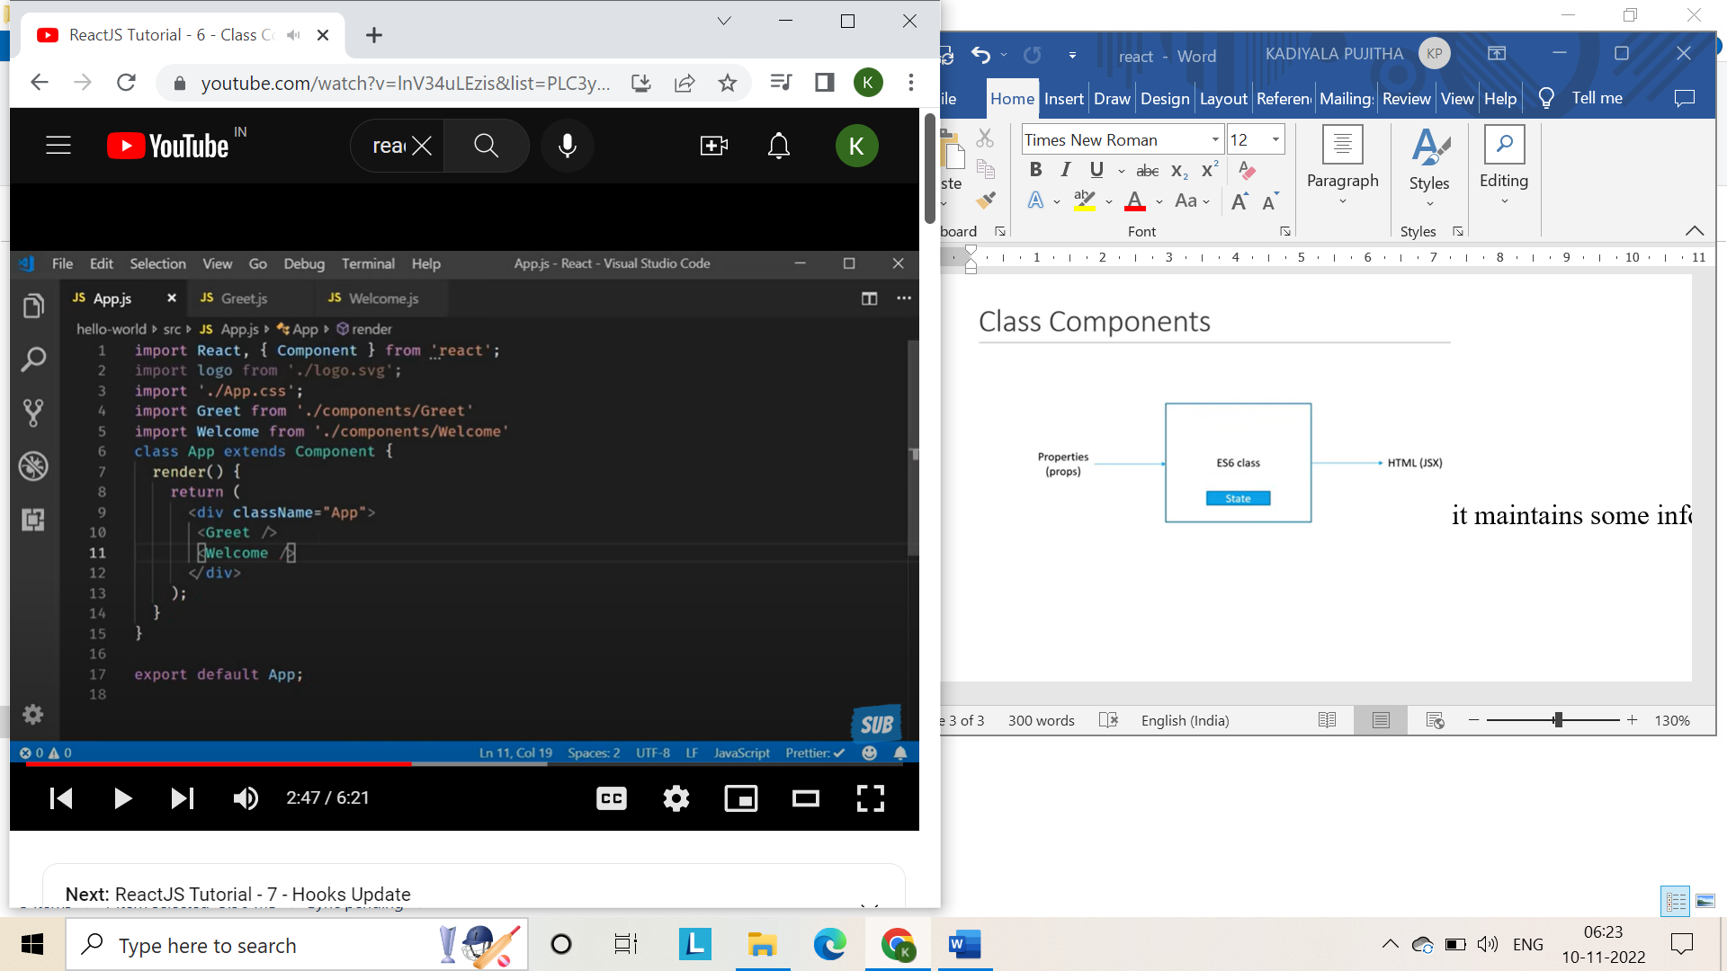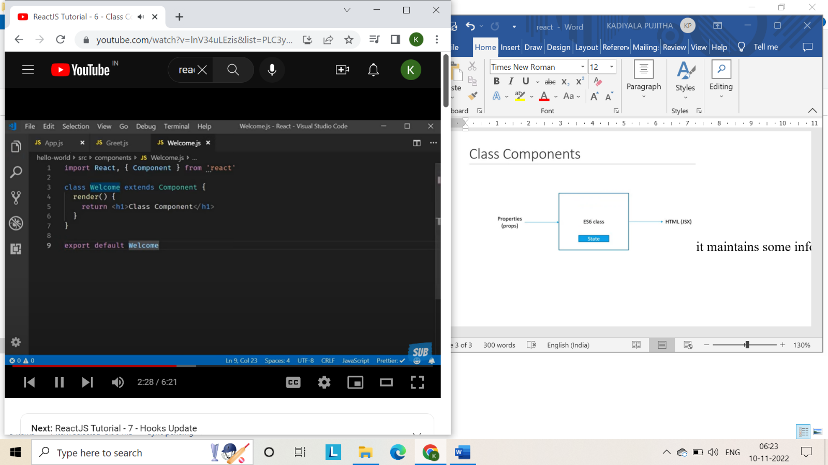

Functional components receive props and returns states and no complicated logic.

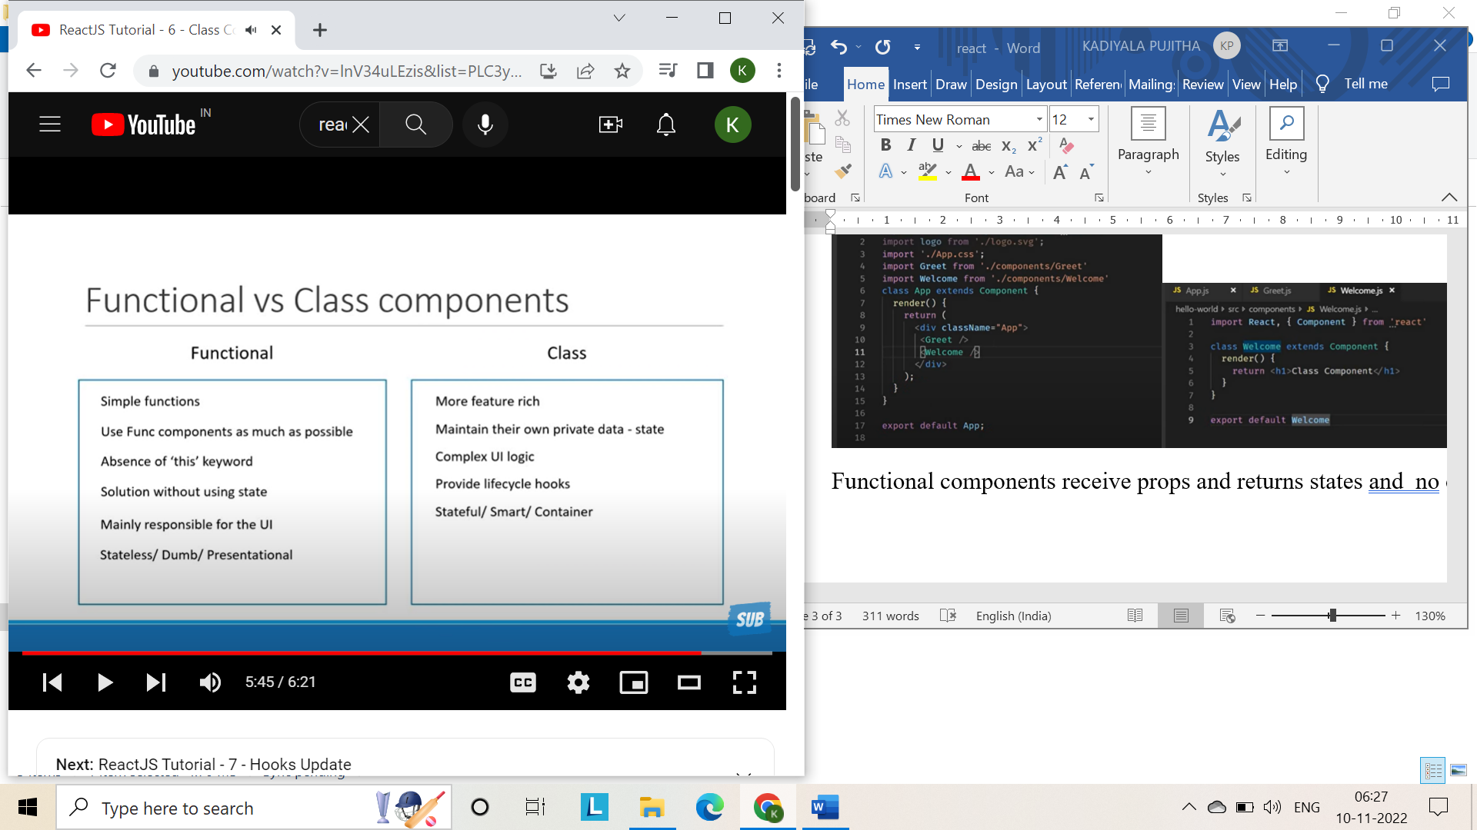

Hooks update:

No breaking changes

Completely opt-in and 100% backwards compatible

Whatever we’ve learned so far in this series still holds good

Component types- functional components and class components

Using state, lifecycle methods and this binding



With and without jsx:

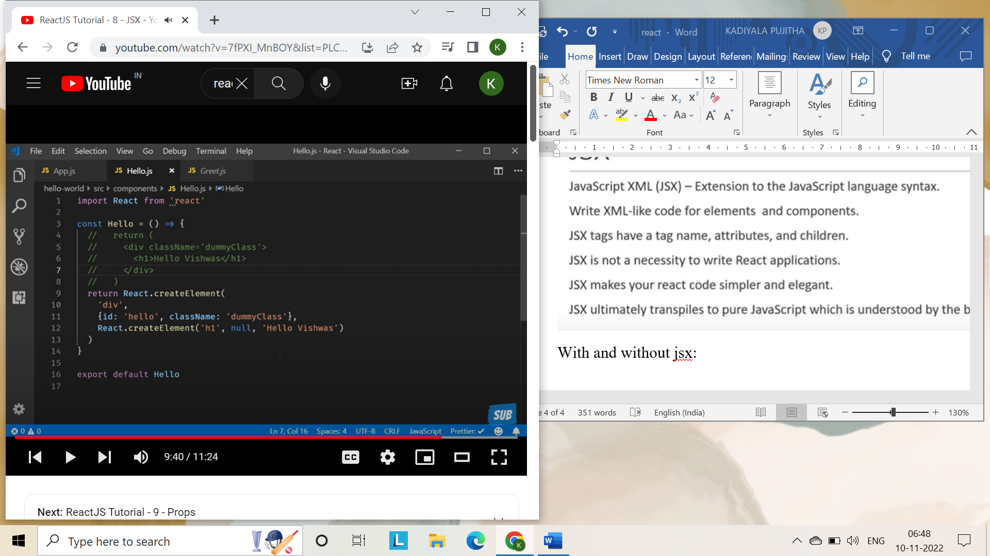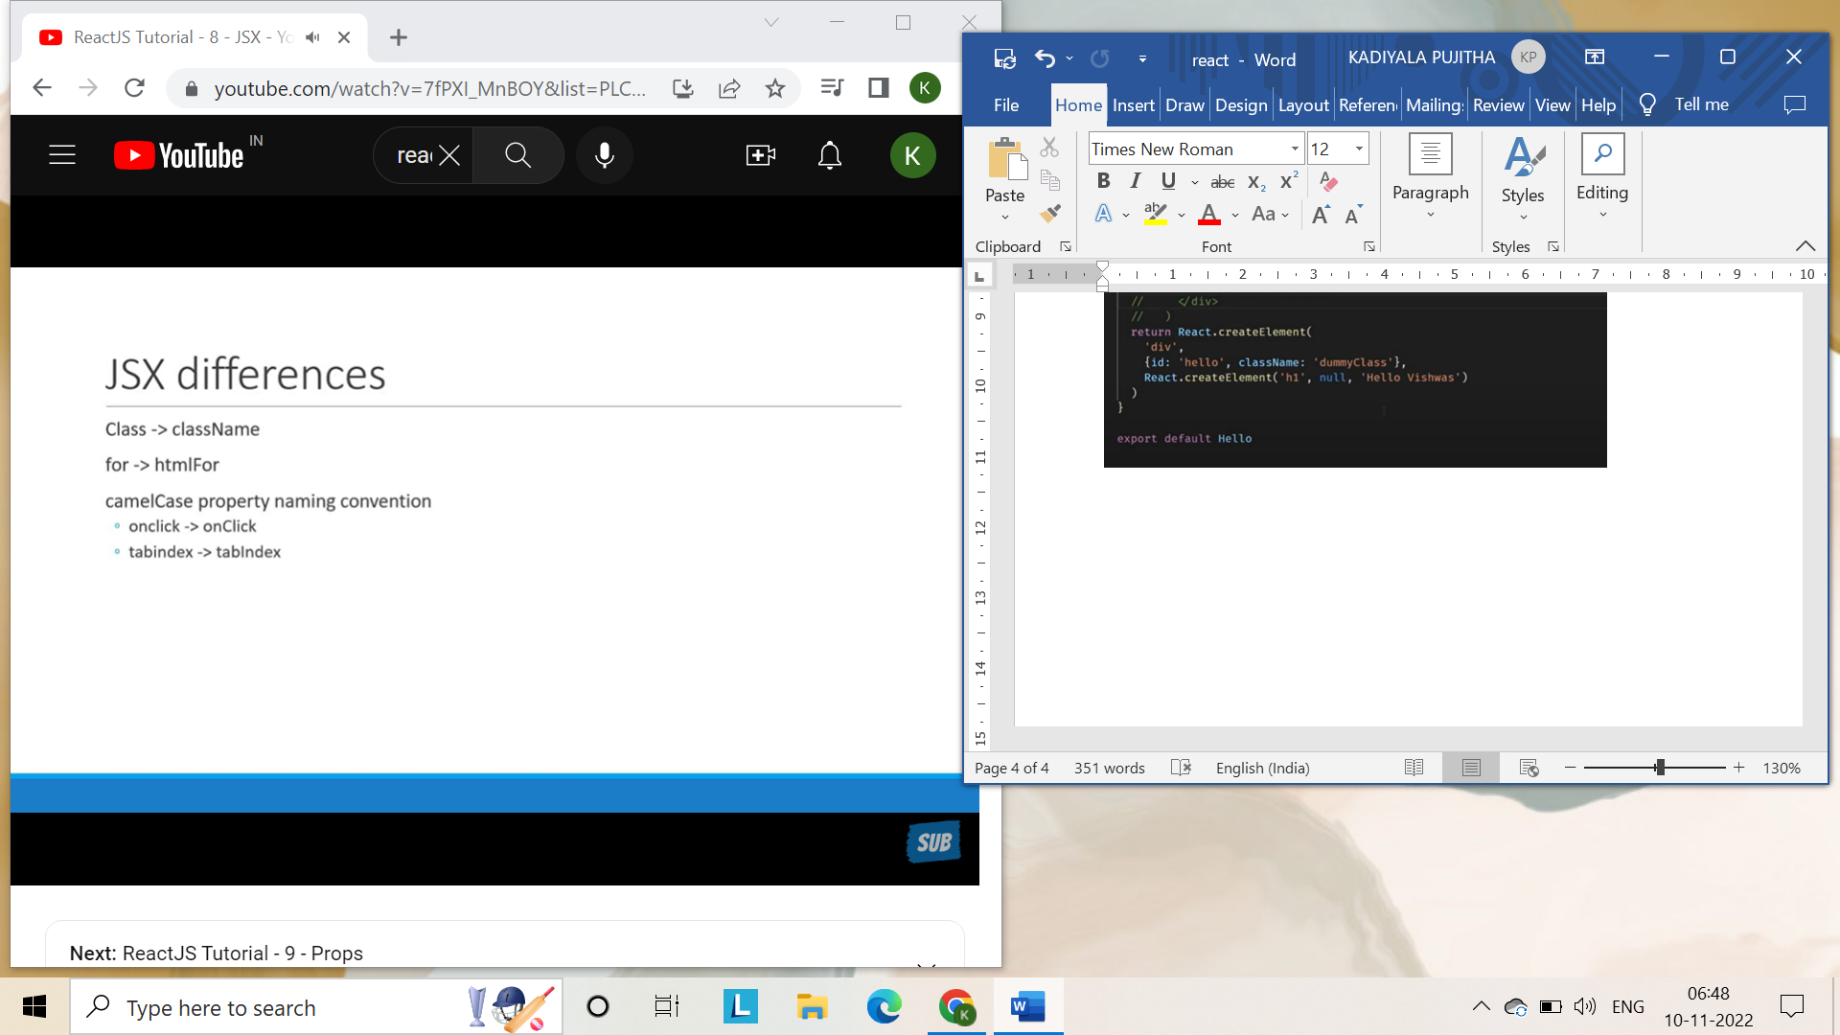

**Props:**

props short for properties, is the optional input that your component can accept.

It also allows the component content to be dynamic.

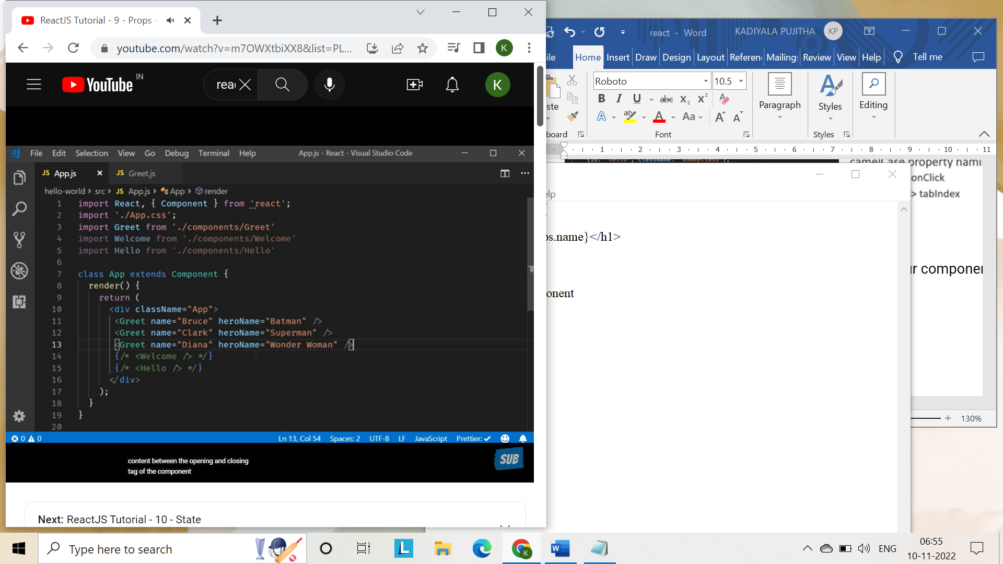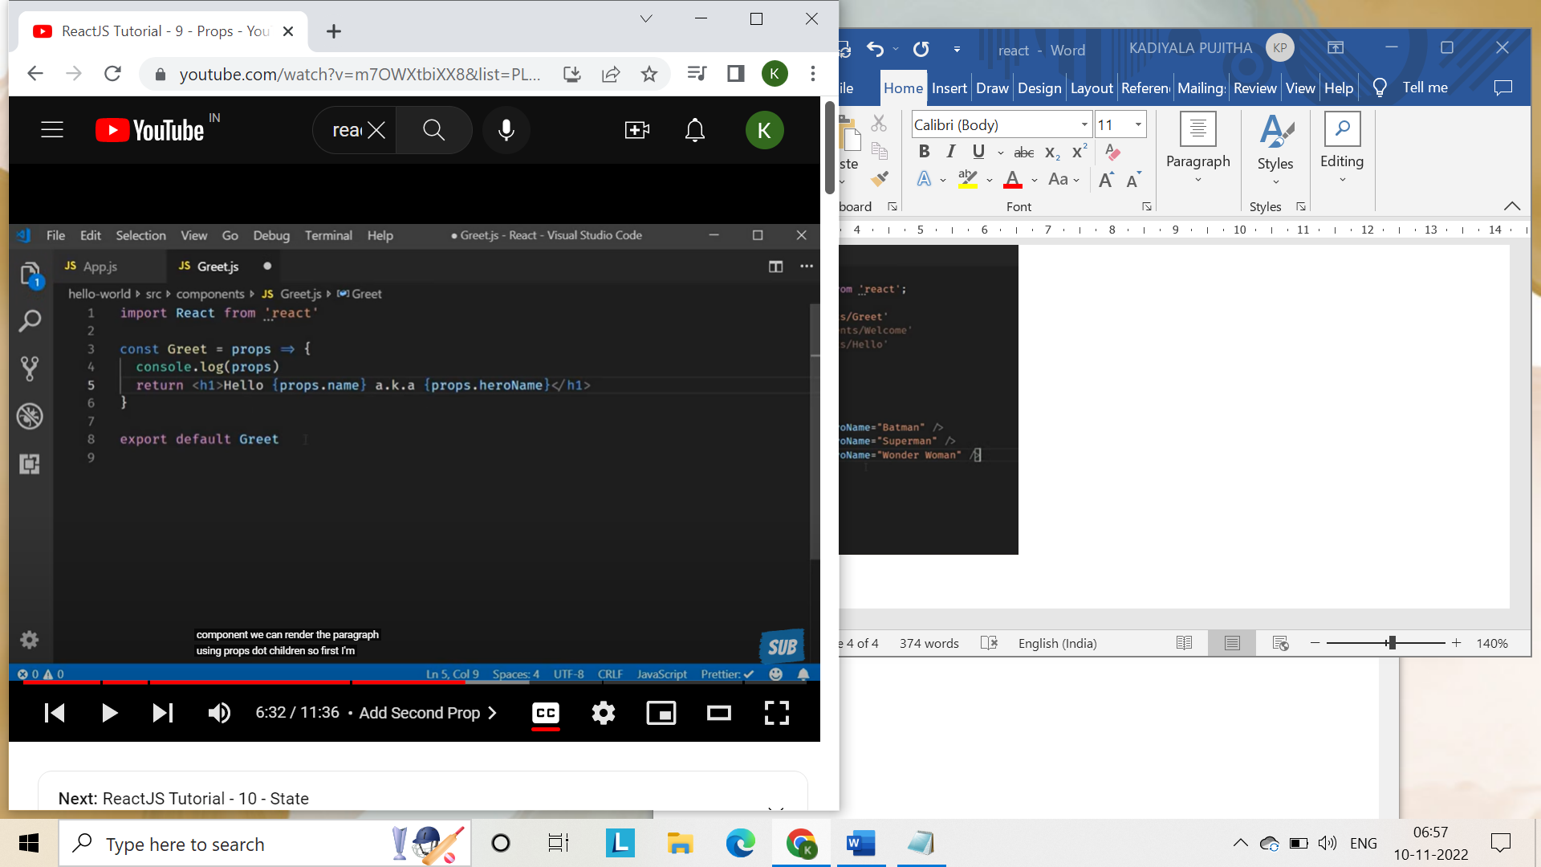

We can return only one html element.

If you don’t know what you are passing pass them in between starting and closing tags and render them in components file as {props.children}

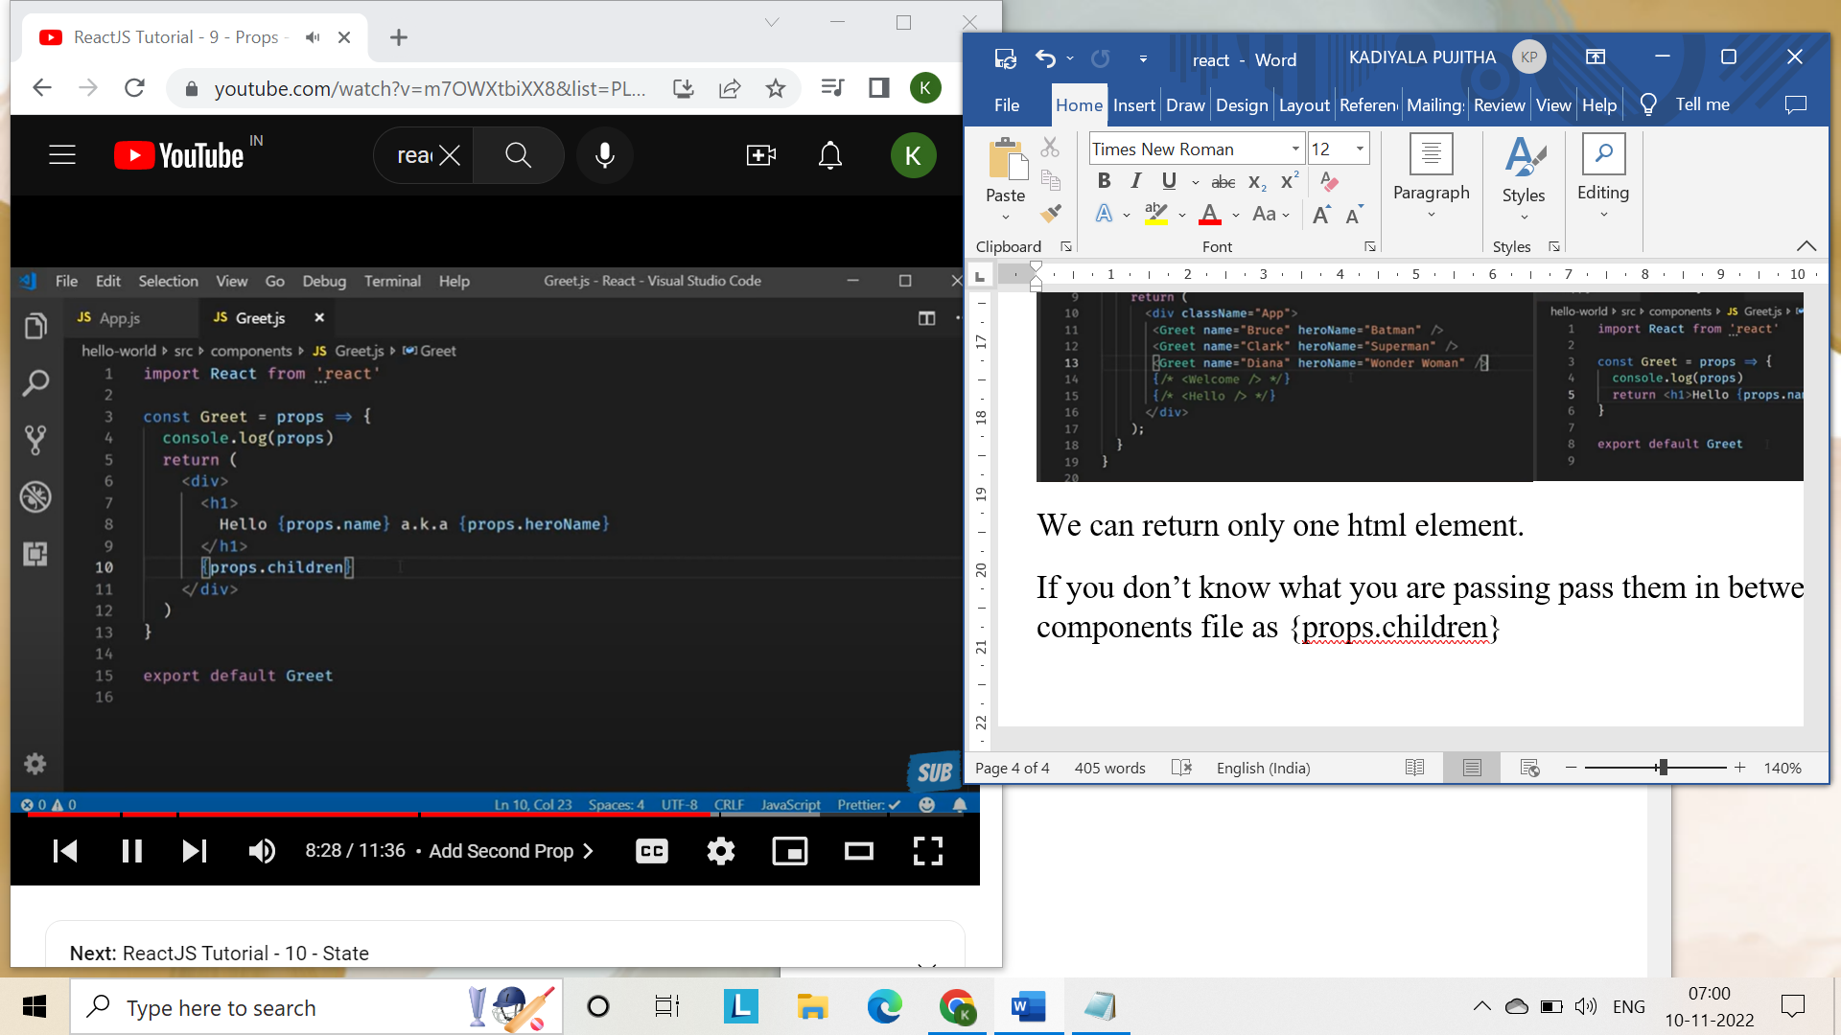 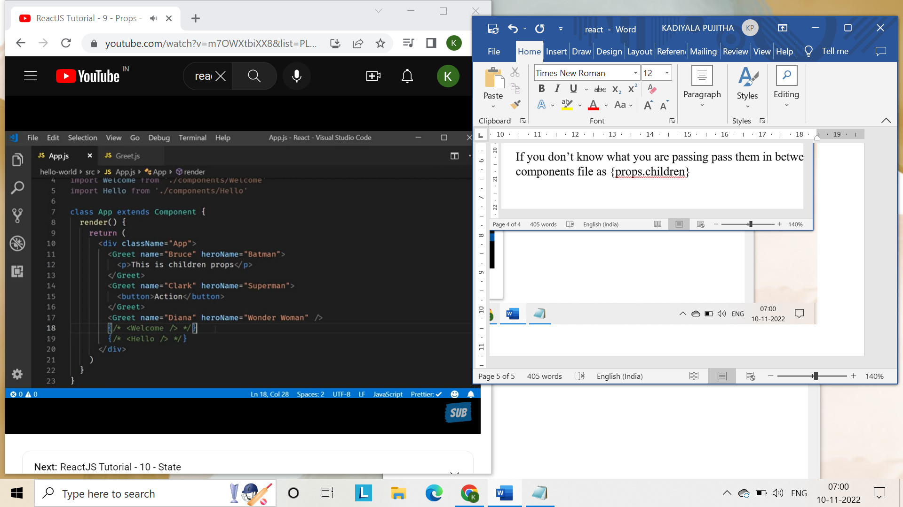

**Props using class components:** 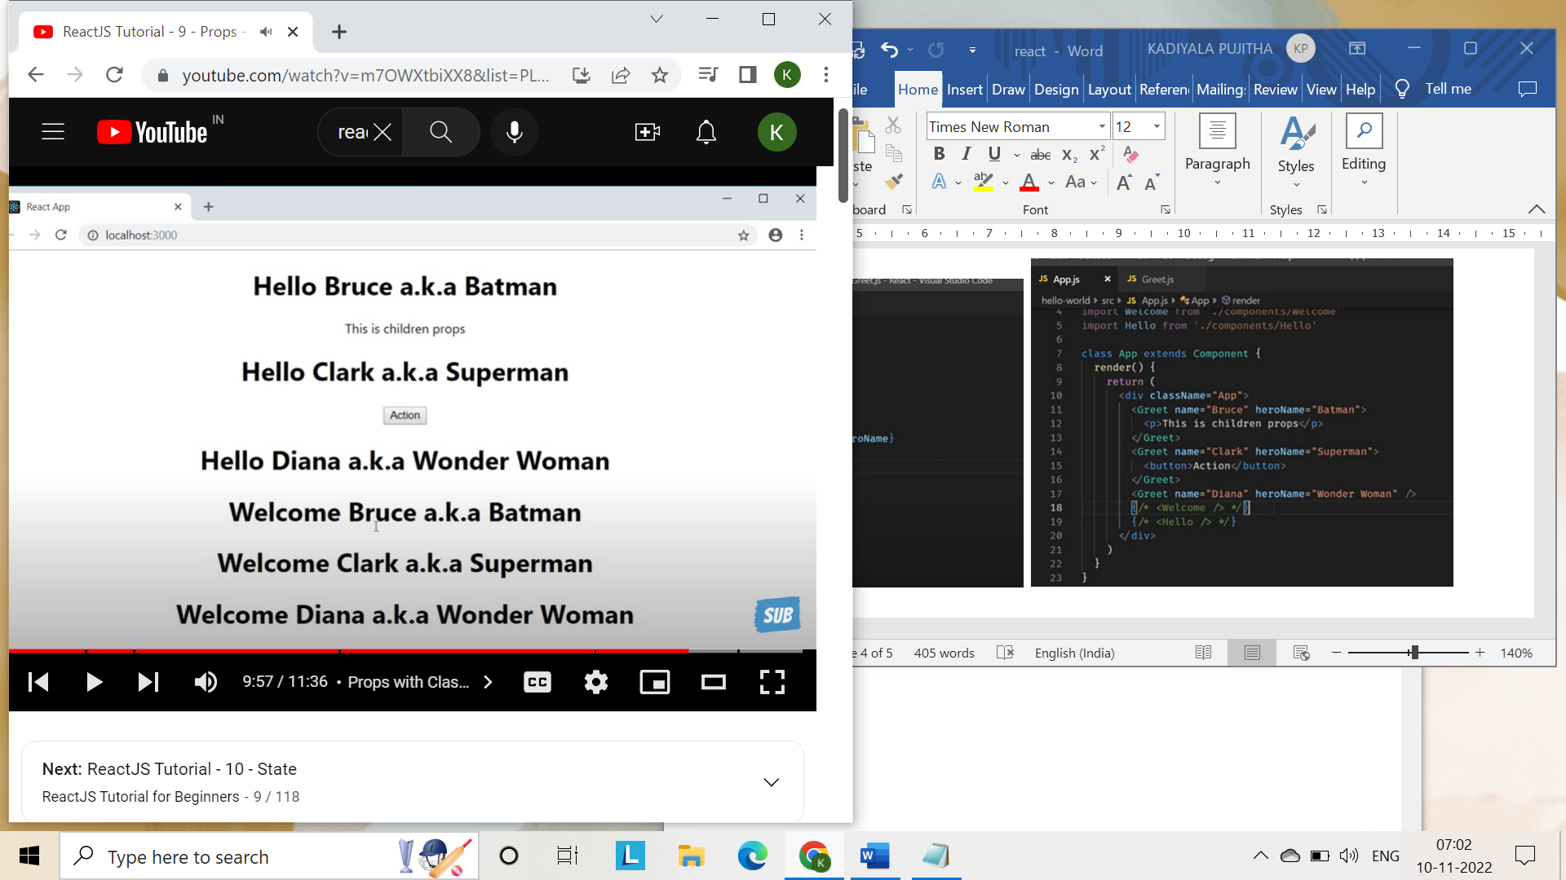

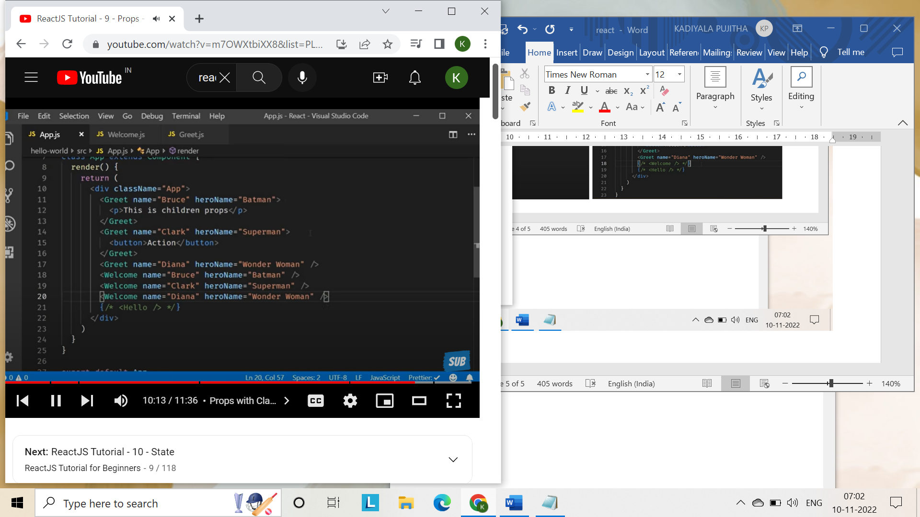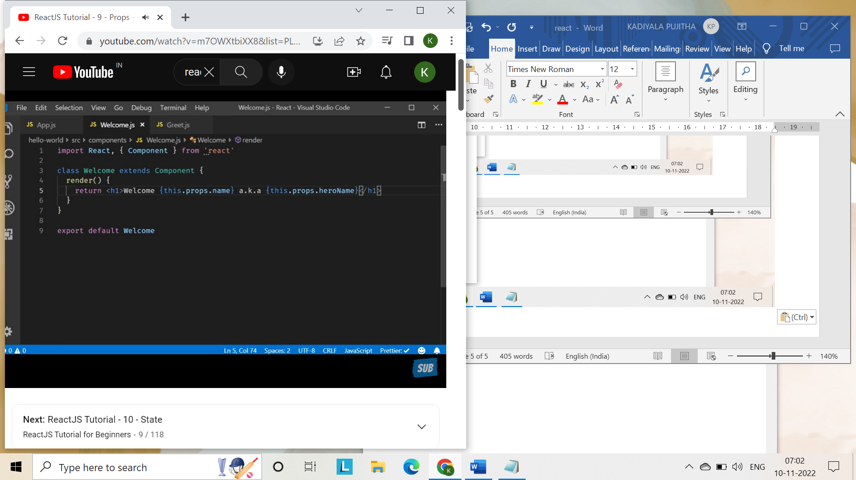

If props are immutable how is it possible to .. parents owns the props and cannot be changed by children.

**State:**

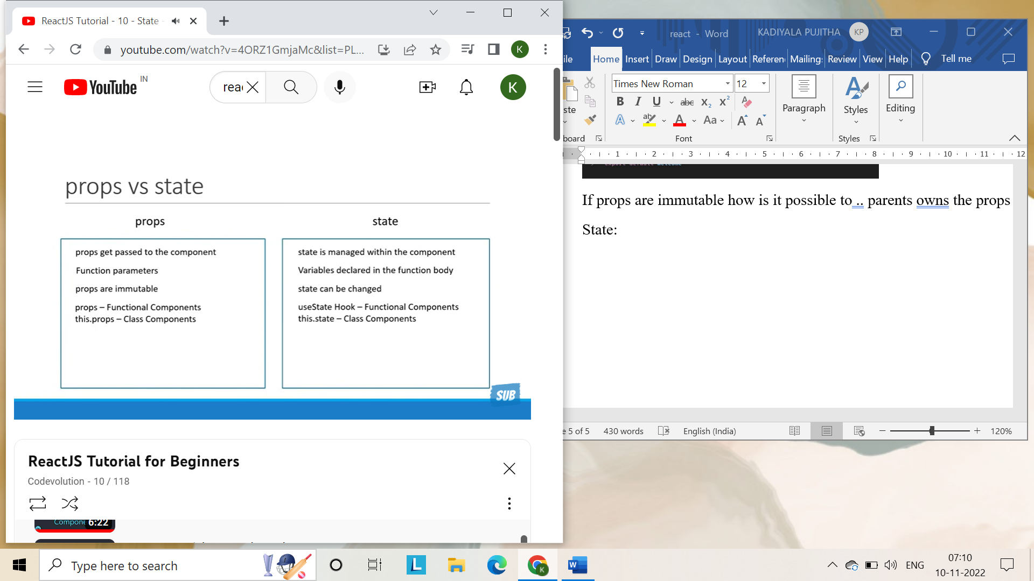

Component: message.js

import React,{Component} from 'react'

class Message extends Component{

    constructor(){

        super()

        this.state={

            Message:'Welcome visitor'

        }

    }

    changeMessage()

    {

        this.setState({

            Message:'Thank you for subscribing'

        })

    }

    render(){

        return (

            <div>

                <h1>{this.state.Message}</h1>

                <button onClick={()=> this.changeMessage()}>Subscribe</button>

            </div>

        )

    }

}

export default Message

App.js;

import './App.css'

import React,{Component} from 'react'

import Message from './components/Message'

class App extends Component{

  render(){

    return(

     <div className="App">

      <Message/>

     </div>

    )

  }

}

**setState:**

never modify the state directly we should use setState so react knows what to render

calls to setState is asynchronous.

It has two parameters first is state object, call back function it is an arrow function.

Whenever you need to execute some code after state has been changed do not place that code right after the set state method instead place it in a callback function that is a second parameter of setState.

import React,{Component} from 'react'

class Counter extends Component{

    constructor(props){

        super(props)

        this.state={

            count:0

        }

    }

    increment(){

        this.setState({count:this.state.count+1},

            ()=>{console.log('Callback value',this.state.count)})

        console.log(this.state.count)

    }

    render(){

        return(

            <div>

                Count - {this.state.count}

                <button onClick={()=>this.increment()}>Increment</button>

            </div>

        )

    }

}

export default Counter

so whenever you have to update the state based on the previous state you need to pass function as an argument to set state method instead of passing in an object

import React,{Component} from 'react'

class Counter extends Component{

    constructor(props){

        super(props)

        this.state={

            count:0

        }

    }

    increment(){

        this.setState(prevState=>({

            count:prevState.count+1

        }))

    }

    incrementFive(){

        this.increment()

        this.increment()

        this.increment()

        this.increment()

        this.increment()

    }

    render(){

        return(

            <div>

                Count - {this.state.count}

                <button onClick={()=>this.incrementFive()}>Increment</button>

            </div>

        )

    }

}

export default Counter

function will have the access to prevState. You can use function parameter approach and make use of props.

this.setState(prevState,props)=>({

count:prevState.count+props.addValue

}

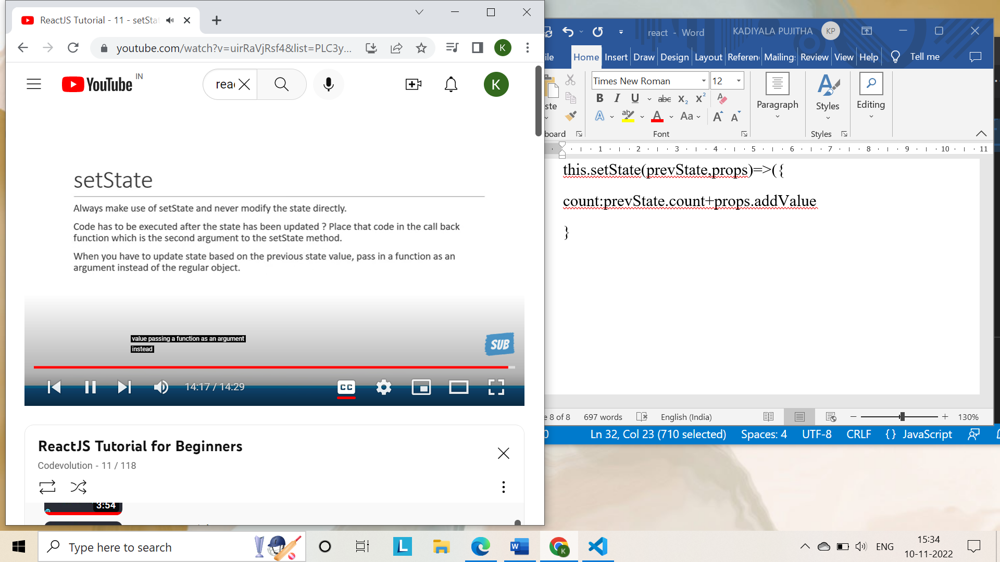

**DE structuring props and states:**

Es6 feature it is makes it possible to unpack values from arrays or properties from objects into distinct variables.

Welcome.js

import React,{Component} from 'react'

class Welcome extends Component{

    render(){

        return (

            <h1>

                Welcome {this.props.name} a.k.a {this.props.heroName}

            </h1>

        )

    }

}

export default Welcome

Greet.js:

import React from 'react'

const Greet= props =>{

console.log(props)

return(

    <div>

        <h1>Hello {props.name} a.k.a {props.heroName}

        </h1>

    </div>

)

}

export default Greet

app.js:

import './App.css'

import React,{Component} from 'react'

import Message from './components/Message'

import Counter from './components/Counter'

import Greet from './components/Greet'

import Welcome from './components/Welcome'

class App extends Component{

  render(){

    return(

     <div className="App">

      {/* <Message/>

      <Counter/> */}

      <Greet name="Bruce" heroName="BatMan">

      <p>This is children property</p>

      </Greet>

      <Greet name="Clark" heroName="Superman">

        <button>Action</button>

      </Greet>

      <Greet name="Diana" heroName="Wonder woman"/>

      <Welcome name="Bruce" heronName="Batman"/>

      <Welcome name="Clark" heronName="Superman"/>

      <Welcome name="Diana" heronName="Wonder woman"/>

     </div>

    )

  }

}

export default App;

In react destructuring props and states lead to code readability.

Two ways to destructure props in functional components:

1. **Destructure it in functional parameters**

Const Greet=({name, heroName})=>

So we can use name and heroName directly instead of using props.name and props.heroName.

import React from 'react'

const Greet= ({name,heroName}) =>{

return(

    <div>

        <h1>Hello {name} a.k.a {heroName}

        </h1>

    </div>

)

}

export default Greet

1. **Destructuring in the function body:**

const Greet = props =>{

    const {name, heroName}=props

    return(

        <div>

            <h1>Hello {name} a.k.a {heroName} </h1>

        </div>

    )

}

**Destructure props and states in class components**

We destructure in render():

import React,{Component} from 'react'

class Welcome extends Component{

    render(){

        const {name, heroName}=this.props

        return (

            <h1>

                Welcome {name} a.k.a {heroName}

            </h1>

        )

    }

}

export default Welcome

state syntax:

const {state1, state2}=this.state

**Event handlers:**

Event handling like onClick they should be camel cased and you pass a function as the event handler rather than a string so instead of click.

We want event handler to be a function not a function call

* In class component we access the methods using this keyword
* But usually event handlers tend to modify the state of the component using this.setState()

FunctionClick.js

import React from "react";

function FunctionClick(){

    function clickHandler(){

        console.log("Button clicked")

    }

    return(

        <div>

            <button onClick={clickHandler}>Click</button>

        </div>

    )

}

export default FunctionClick

classclick.js:

import React,{Component} from "react";

class ClassClick extends Component{

    clickHandler(){

        console.log("Clicked the button")

    }

    render(){

        return(

            <div>

                <button onClick={this.clickHandler}>Click me</button>

            </div>

        )

    }

}

export default ClassClick

**Bind Event Handlers in react:**

It is because purely because of the way this keyword works:

This keyword within event handler is undefined and this is why binding is necessary for even handlers.

Every update to the state will cause the component to rerender. This generates a brand-new event handler on every render.

1. **Binding in the render method:** cannot be used because of performance implications.

import React,{Component} from "react";

class EventBind extends Component{

    constructor(props){

        super(props)

        this.state={

            message:'Hello'

        }

    }

    clickHandler(){

        this.setState({

            message:'GoodBye'

        })

        console.log("GoodBye")

    }

    render(){

        return(

            <div>

                <div>{this.state.message}</div>

                <button onClick={this.clickHandler.bind(this)}>Click</button>

            </div>

        )

    }

}

export default EventBind

1. **Using arrow functions in render method:**

We don’t require curly braces or return keyword for arrow function body because the function body is a single statement

import React,{Component} from "react";

class EventBind extends Component{

    constructor(props){

        super(props)

        this.state={

            message:'Hello'

        }

    }

    clickHandler(){

        this.setState({

            message:'GoodBye'

        })

        console.log("GoodBye")

    }

    render(){

        return(

            <div>

                <div>{this.state.message}</div>

                <button onClick={() => this.clickHandler()}>Click</button>

            </div>

        )

    }

}

export default EventBind

1. **Binding in the constructor:** Official approach deals with binding the event handler in the constructor as opposed to binding in the render method.

import React,{Component} from "react";

class EventBind extends Component{

    constructor(props){

        super(props)

        this.state={

            message:'Hello'

        }

        this.clickHandler=this.clickHandler.bind(this)

    }

    clickHandler(){

        this.setState({

            message:'GoodBye'

        })

        console.log("GoodBye")

    }

    render(){

        return(

            <div>

                <div>{this.state.message}</div>

                <button onClick={this.clickHandler}>Click</button>

            </div>

        )

    }

}

export default EventBind

1. **Use arrow function as a class property**: basically, change the way u define a method in the class.

import React,{Component} from "react";

class EventBind extends Component{

    constructor(props){

        super(props)

        this.state={

            message:'Hello'

        }

    }

    clickHandler =()=>{

        this.setState({

            message:'GoodBye'

        })

    }

    render(){

        return(

            <div>

                <div>{this.state.message}</div>

                <button onClick={this.clickHandler}>Click</button>

            </div>

        )

    }

}

export default EventBind

**Methods as props:**

Parent component can pass down props to its children components when the data in the parent component when passed as props is available in the children componets.

**What if child component wanted to communicate with the parent component?**

This time we are passing a reference to a method as props to the child component

Backticks and dollar curly braces is a feature in es6 and is not a feature specific to react (template literals)

* We can call a method in parent component from the button in the child component by passing the method as props to the child component

Parentcomponent.js:

import React,{Component} from "react";

import ChildComponent from "./ChildComponent";

class ParentComponent extends Component{

    constructor(props){

        super(props)

        this.state={

            parentName:'Parent'

        }

        this.greetParent=this.greetParent.bind(this)

    }

    greetParent(){

        // alert('Hello '+this.state.parentName)

        alert(`Hello ${this.state.parentName}`)

    }

    render(){

        return(

            <div>

                <ChildComponent greetHandler={this.greetParent}/>

            </div>

        )

    }

}

export default ParentComponent

ChildComponent.js:

import React,{Component} from "react";

function ChildComponent(props){

    return(

        <div>

            <button onClick={props.greetHandler}>Greet Parent</button>

        </div>

    )

}

export default ChildComponent

**How to pass a parameter when calling the parent methods from the child component?**

* An arrow function in return statement is used. Arrow function syntax is simplest way to pass parameter from the child component to the parent component.

Parentcomponent:

import React,{Component} from "react";

import ChildComponent from "./ChildComponent";

class ParentComponent extends Component{

    constructor(props){

        super(props)

        this.state={

            parentName:'Parent'

        }

        this.greetParent=this.greetParent.bind(this)

    }

    greetParent(childName){

        // alert('Hello '+this.state.parentName)

        alert(`Hello ${this.state.parentName} from ${childName}`)

    }

    render(){

        return(

            <div>

                <ChildComponent greetHandler={this.greetParent}/>

            </div>

        )

    }

}

export default ParentComponent

child component:

import React,{Component} from "react";

function ChildComponent(props){

    return(

        <div>

            <button onClick= {()=>props.greetHandler('child')}>Greet Parent</button>

        </div>

    )

}

export default ChildComponent

**Conditional Rendering:**

When you are building react applications you may often need to show or hide some html based on a certain condition

Conditional rendering works the same way conditions work in javascript.

1. If/else
2. Element variables
3. Ternary conditional operator
4. Short circuit operator

Example 1:

import React, { Component } from 'react'

class UserGreeting extends Component {

    constructor(props){

        super(props)

        this.state={

            isLoggedIn:true

        }

    }

  render() {

    if(this.state.isLoggedIn){

        return(

            <div>Welcome Pujitha</div>

        )

    }

    else

    return (

        <div>Welcome Guest</div>

    )

  }

}

export default UserGreeting

if else stmt don’t work inside jsx and is not valid

Jsx is syntactic suger for function calls and object construction

Example 2:

import React, { Component } from 'react'

class UserGreeting extends Component {

    constructor(props){

        super(props)

        this.state={

            isLoggedIn:true

        }

    }

  render() {

    let message

    if(this.state.isLoggedIn)

    message=<div>Welcome Pujitha</div>

    else

    message=<div>Welcome Guest</div>

    return <div>{message} </div>

  }

}

export default UserGreeting

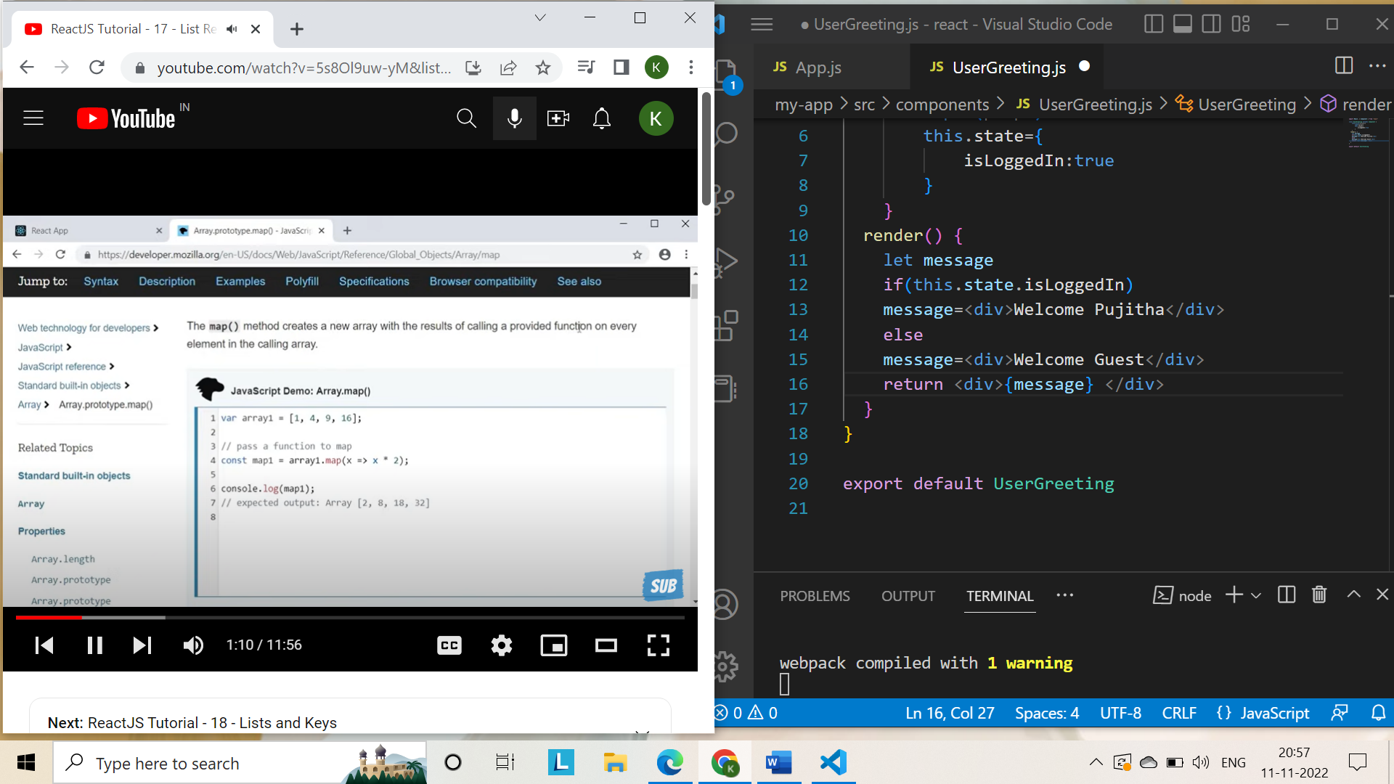

Example 3: conditional operator

import React, { Component } from 'react'

class UserGreeting extends Component {

    constructor(props){

        super(props)

        this.state={

            isLoggedIn:true

        }

    }

  render() {

    return this.state.isLoggedIn ?(<div>Welcome Pujitha</div>):

    (<div>Welcome Guest</div>)

  }

}

export default UserGreeting

while building web application sometimes we display list of products or courses for that what we want is to repeat some html for each item in the list.

import React from 'react'

function NameList() {

    const names=['Bruce', 'Clark', 'Diana']

  return (

    <div>

      <h2>{names[0]}</h2>

      <h2>{names[1]}</h2>

      <h2>{names[2]}</h2>

    </div>

  )

}

export default NameList

Lets see how to use the map method to render the list of names

import React from 'react'

function NameList() {

    const names=['Bruce', 'Clark', 'Diana']

    const nameList=names.map(name=><h2>{name}</h2>)

  return (

    <div>{nameList}

    </div>

  )

}

export default NameList

List of objects with few properties have to be rendered in that case we refactor the jsx into a separate component and then use the component in the map method jsx.

List component is only responsible for rendering the list and the person component is only responsible for rendering the person html

When building applications that render lists of data

NameList.js

import React from 'react'

import Person from './Person'

function NameList() {

   const persons=[

    {

      id:1,

      name1:'Bruce',

      age:30,

      skill:'React'

    },

    {

      id:2,

      name1:'Clark',

      age:25,

      skill:'Angular'

    },

    {

      id:3,

      name1:'Diana',

      age:28,

      skill:'Vue'

    }

   ]

   const personsList=persons.map(person=><Person person={person}/>)

   return <div>{personsList}</div>

}

export default NameList

Person.js:

import React from 'react'

function Person({person}) {

  return (

    <div>

      <h2>I am {person.name1}. I am {person.age} years old. I know {person.skill}</h2>

    </div>

  )

}

export default Person

**Lists and Keys**

Each child in a list should have a unique "key" prop.

A “key” is a special string attribute you need to include when creating lists of elements.

Keys give the elements a stable identity.

Keys help React identify which items have changed, are added, or are removed.

This results in a much more efficient update of the user interface.

To prop we need to assign a value that will be unique within the list.

Key prop can be id or name so that it can be unique.

Key prop is not accessible in the child component.

      <h2> {key} I am {person.name1}. I am {person.age} years old. I know {person.skill}</h2>

It is invalid. If you want to pass it down pass it as different prop

React just iterates over both the lists at the same time and generates a mutation whenever there is a difference. React simply inserts the item at the end of the list. For first example, but for the second one difference is at the starting only so react makes a comparison and it finds out that every item is different. React ends up mutating every child instead of realising to keep bruce and clark in tact.

To support this issue react uses key attributes when children have keys. React uses key to match the children in the original tree with the children in the subsequent tree

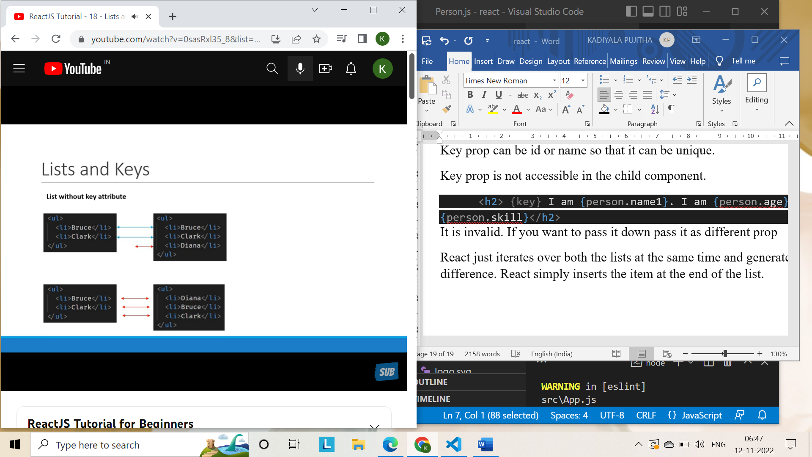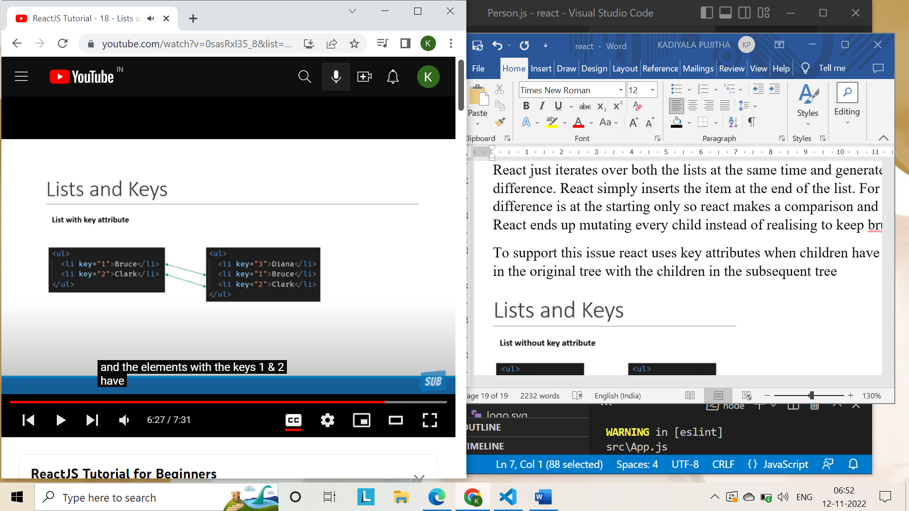

**Index as an anti-pattern:**

import React from 'react'

import Person from './Person'

function NameList() {

  const names=['Bruce','Clark','Diana']

   const nameList=names.map(name=><h2>{name}</h2>)

   return <div>{nameList}</div>

}

export default NameList

it gives error in console as it need a unique key, it can be fixed if have an attribute that is unique and can act as key, but what if we don’t have a key attribute?

We could use the name itself as the key but what if the names are same?

Keys should be unique so that components maintain their identity across updates. Non-unique keys may cause children to be duplicated and/or omitted — the behavior is unsupported and could change in a future version.

We can use an index as a second parameter to the arrow function and it acts as a key.

import React from 'react'

import Person from './Person'

function NameList() {

  const names=['Bruce','Clark','Diana']

   const nameList=names.map((name,index)=><h2 key={index}>{index} {name}</h2>)

   return <div>{nameList}</div>

}

export default NameList

using index as a key will cause some serious ui issues in certain scenarios



**Styling React components:**

1. CSS stylesheets
2. Inline styling
3. CSS Modules
4. CSS in JS Libraries (Styled components)

Example **css style sheets:**

App.js:

StyleSheet primary={false}/>

Stylesheet.js:

Example1:

import React from 'react'

import './myStyle.css'

function StyleSheet() {

  return (

    <div>

      <h1 className=’primary’>StyleSheets</h1>

    </div>

  )

}

export default StyleSheet

Example2:

import React from 'react'

import './myStyle.css'

function StyleSheet(props) {

    let className=props.primary?'primary':''

  return (

    <div>

      <h1 className={className}>StyleSheets</h1>

    </div>

  )

}

export default StyleSheet

myStyle.css:

.primary{

    color:orange;

}

Example3:

import React from 'react'

import './myStyle.css'

function StyleSheet(props) {

    let className=props.primary?'primary':''

  return (

    <div>

      <h1 className={`${className} font-xl`}>StyleSheets</h1>

    </div>

  )

}

export default StyleSheet

**inline:**

Inline styles are not specified as a string instead they are specified with an object whose key is a camel cased version of the style name and the value is usually a string.

Create an object and apply it to style attribute in inline styling.

import React from 'react'

 const heading={

    fontSize:'72px',

    color:'blue'

 }

function Inline() {

  return (

    <div>

      <h1 style={heading}>Inline</h1>

    </div>

  )

}

export default Inline

**CSS modules:**

File naming convention to be used for css modules with create react app

File name must be suffixed with dot module dot css

Classes are locally scoped by default

import './appStyle.css'

import styles from './appStyles.module.css'

class App extends Component{

  render(){

    return(

     <div className="App">

      {

        <>

        <h1 className='error'>Error</h1>

        <h1 className={styles.success}>Success</h1>

        </>

</div>

    )

  }

}

inline styling - it is an object with camelCase styles

modules - applies only to specified component. as it is imported as a variable. so wont apply inside other components... and cant be used in children component.

where as other styles - apply to all child components.

**Basics of form handling:**

In regular html form elements like input text area are responsible on their own to handle the user input and update the respective values.

For react to control the form elements instead such form elements whose values is controlled by react is called a controlled component.

import React, { Component } from 'react'

export class Form extends Component {

    constructor(props){

        super(props)

        this.state={username:'',comments:'',topic:'react'}

    }

    handleUsernameChange=(event)=>{

        this.setState({username:event.target.value})

    }

    handleCommentsChange=(event)=>{

        this.setState({comments:event.target.value})

    }

    handleTopicChange=(event)=>{

        this.setState({topic:event.target.value})

    }

    handleSubmit=event=>{

        alert(`${this.state.username} ${this.state.comments} ${this.state.topic}`)

        event.preventDefault() //prevents refreshing of the page.

    }

  render() {

    return (

        <form onSubmit={this.handleSubmit}>

        <div>

            <label>Username</label>

            <input

                type="text"

                value={this.state.username}

                onChange={this.handleUsernameChange}/>

        </div>

        <div>

            <label>Comments</label>

            <textarea value={this.state.comments} onChange={this.handleCommentsChange}></textarea>

        </div>

        <div>

            <label>Topic</label>

            <select value={this.state.topic} onChange={this.handleTopicChange}>

                <option value="react">React</option>

                <option value="angular">Angular</option>

                <option value="vue">Vue</option>

            </select>

        </div>

        <div><button type="submit">Submit</button></div>

    </form>

    )

  }

}

export default Form

**Lifecycle methods:**

When we create a component in react a component goes through several stages in its lifecycle.

React provides us with built in methods that we can override at particular stages in the life cycle.

These methods do not exist on a functional component

Life cycle methods in class components

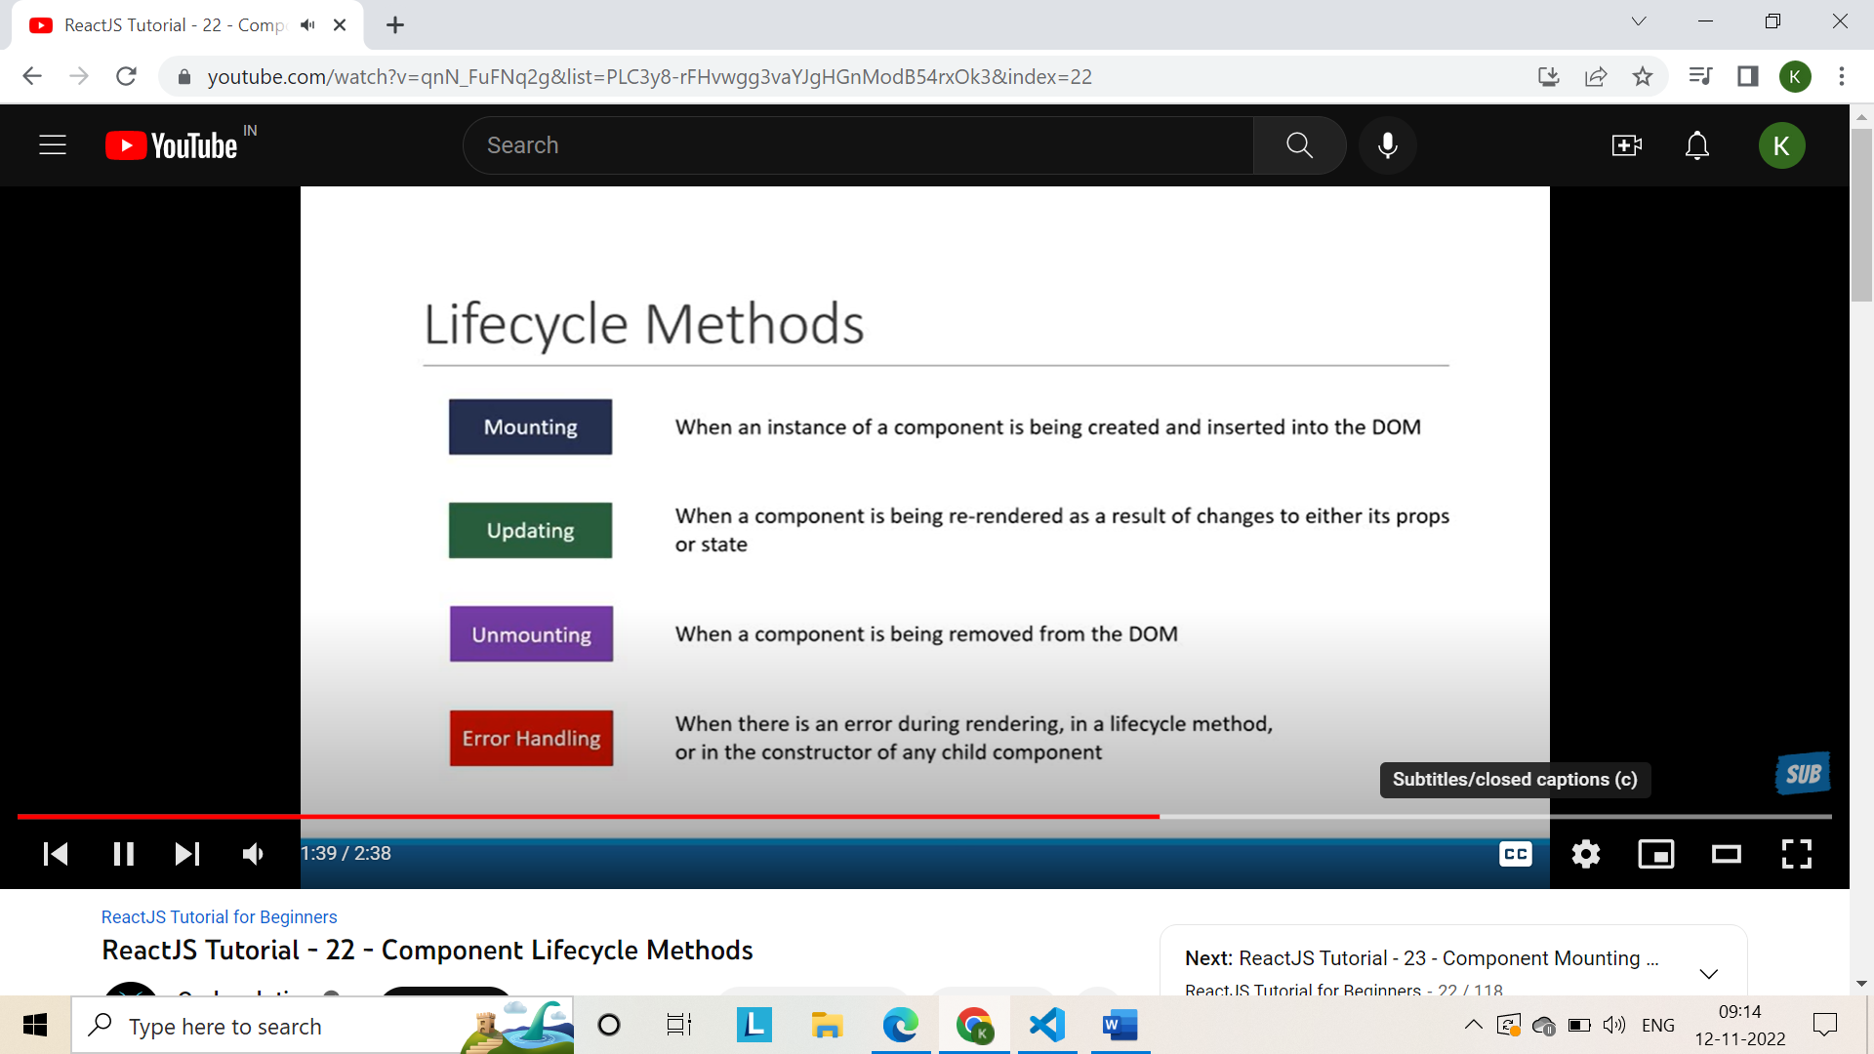

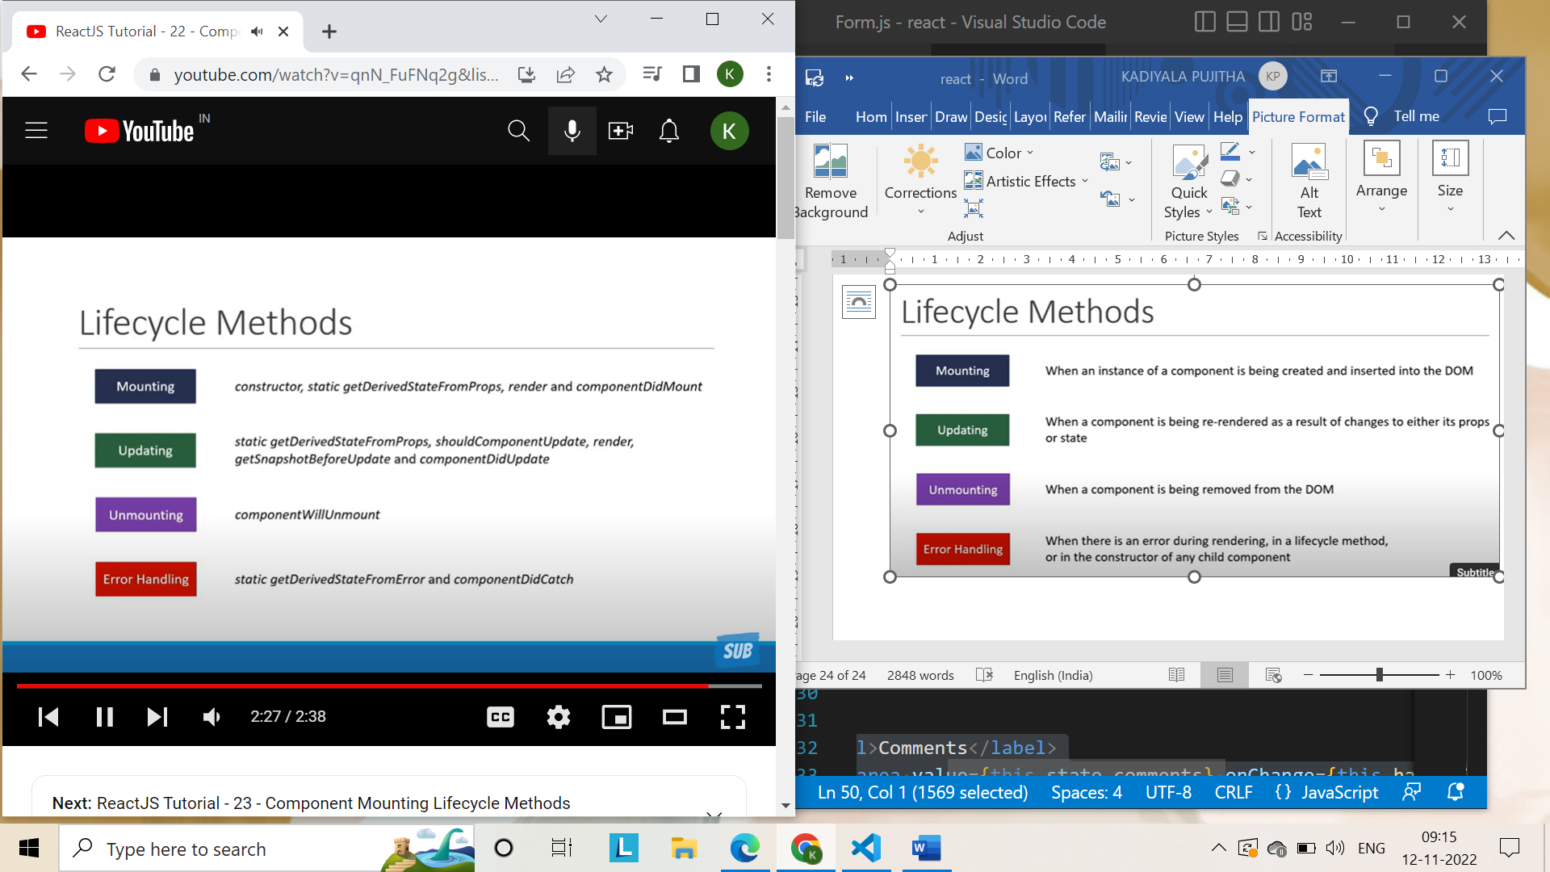

**Mounting Lifecycle methods:**

That is, methods which are called when an instance of a component is being created and inserted into the DOM.

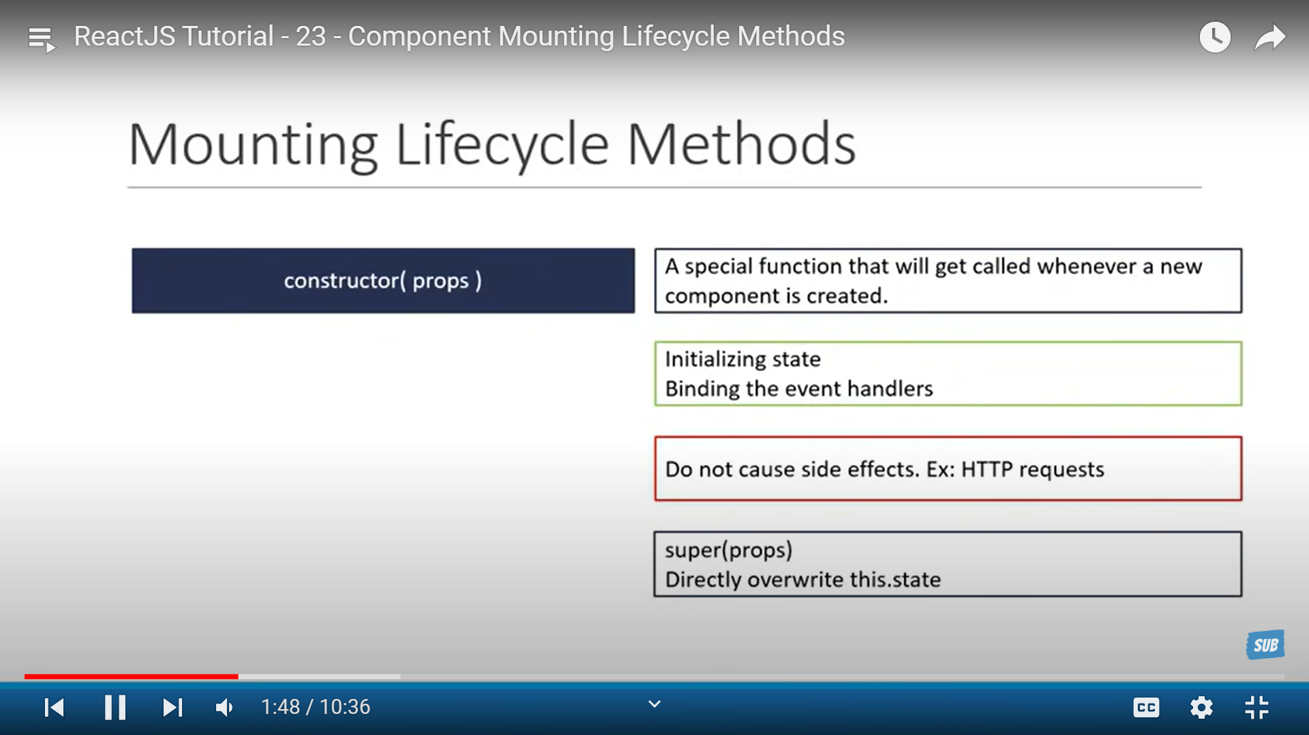

**Fragments:**

Lets you group a list of children elements without adding extra nodes to the DOM

We can replace the existing <div> with a fragment and that will prevent the extra node from being added to the DOM.

If <div> tag is used:

import React from 'react'

function FragmentDemo() {

  return (

    <div >

      <h1>Fragment Demo</h1>

      <p>This describes the fragment demo component</p>

    </div>

  )

}

export default FragmentDemo

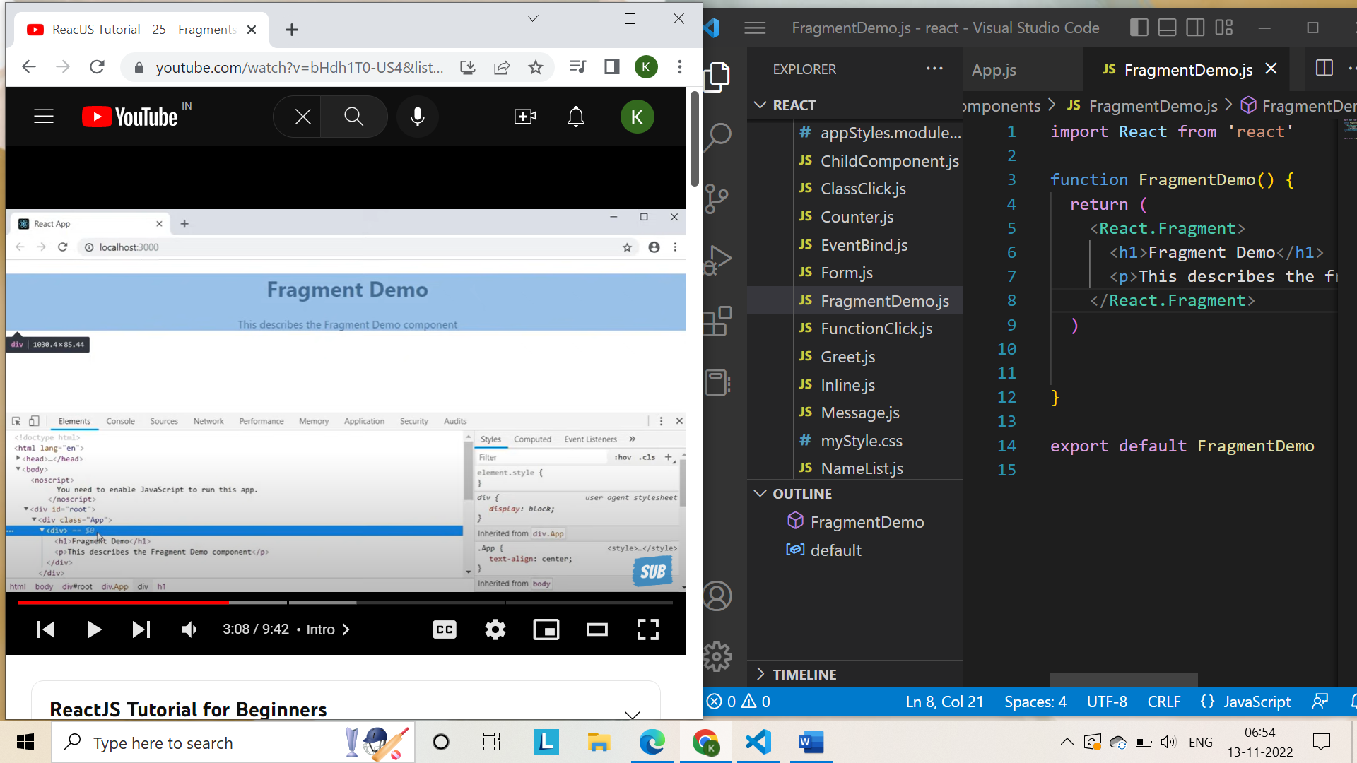

If <React.Fragment> is used:

import React from 'react'

function FragmentDemo() {

  return (

    <React.Fragment>

      <h1>Fragment Demo</h1>

      <p>This describes the fragment demo component</p>

    </React.Fragment>

  )

}

export default FragmentDemo

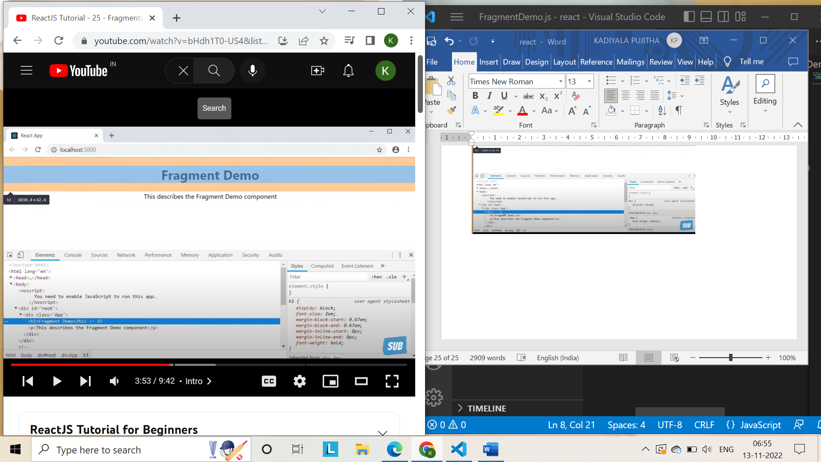

<td> cannot appear as a child of <div>

It is wrong to have <td> element as a child of <div>

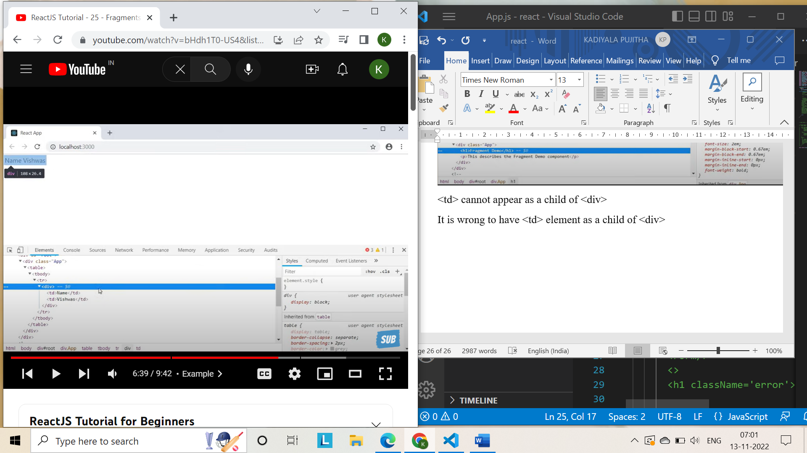

We can use <React.Fragment> in columns.js to avoid this error.

import React from 'react'

function Columns() {

  return (

    <React.Fragment>

      <td>Name</td>

      <td>Pujitha</td>

    </React.Fragment>

  )

}

export default Columns

table.js  
import React from 'react'

import Columns from './Columns'

function Table() {

  return (

    <div>

      <table>

        <tbody>

            <tr>

                <Columns/>

            </tr>

        </tbody>

      </table>

    </div>

  )

}

export default Table

Fragments can accept key attributes when rendering the lists of items

import React from 'react'

function Columns() {

    const items=[]

  return (

    <React.Fragment>

        {

            items.map(item =>(

                <React.Fragment key={item.id}>

                    <h1>Title</h1>

                    <p>{item.title}</p>

                    </React.Fragment>

            ))

        }

      <td>Name</td>

      <td>Pujitha</td>

    </React.Fragment>

  )

}

export default Columns

short hand notation: <> </> here we can’t specify key attributes

**Pure Components:**

We have been creating classes by extending Components

We can also extend using pure component

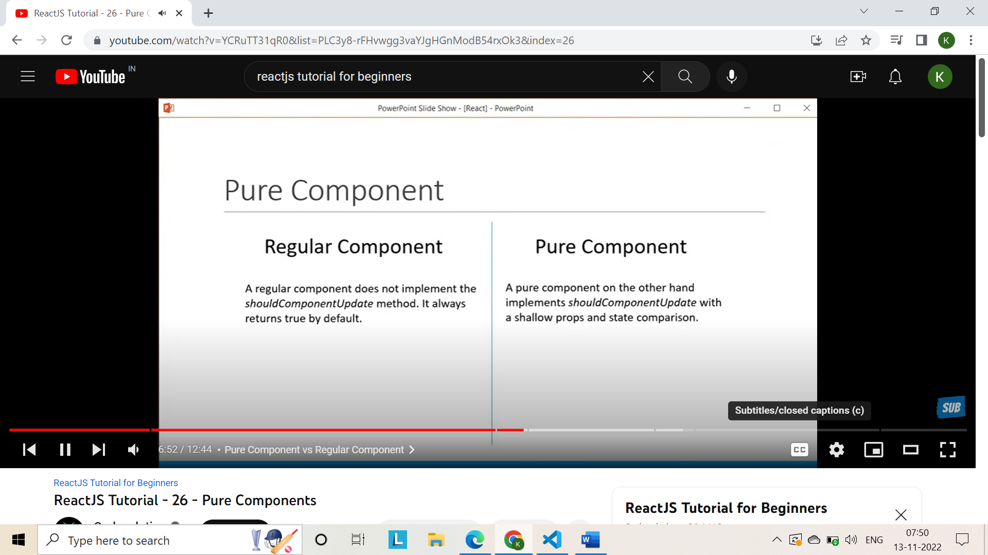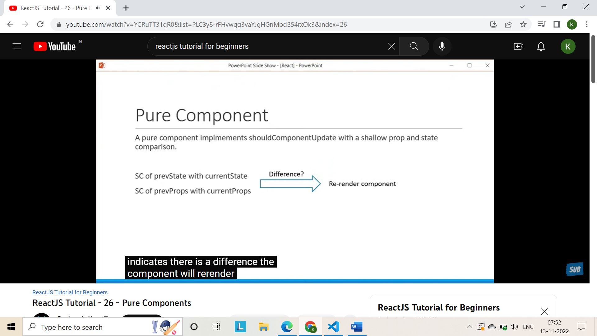

ParentComp.js:

import React, { Component } from 'react'

import PureComp from './PureComp'

import RegComp from './RegComp'

export class ParentComp extends Component {

    constructor(props){

        super(props)

        this.state={name:"Pujitha"}

    }

    componentDidMount(){

        setInterval(()=>{

         this.setState({name:"Pujitha"})

        },2000)

    }

  render() {

    console.log('*********Parent comp render***********')

    return (

      <div>

        Parent Component

        <RegComp name={this.state.name}/>

        <PureComp name={this.state.name}/>

      </div>

    )

  }

}

export default ParentComp

RegularComp.js:

import React, { Component } from 'react'

export class RegComp extends Component {

  render() {

    console.log('Regular component render')

    return (

      <div>

        Regular Component {this.props.name}

      </div>

    )

  }

}

export default RegComp

PureComp.js:

import React, { PureComponent } from 'react'

export class PureComp extends PureComponent {

  render() {

    console.log('Pure component render')

    return (

      <div>

        Pure Component {this.props.name}

      </div>

    )

  }

}

export default PureComp

Only for the first time for every 2 seconds parent regular and pure are printed from the next time we print only parent and regular but not pure. As pure will only re-render if there is a difference in prevProps with current props it does the shallow comparison.

Hence the name is same and there is no difference i.e., pujitha twice so pure component is not re-rendered.

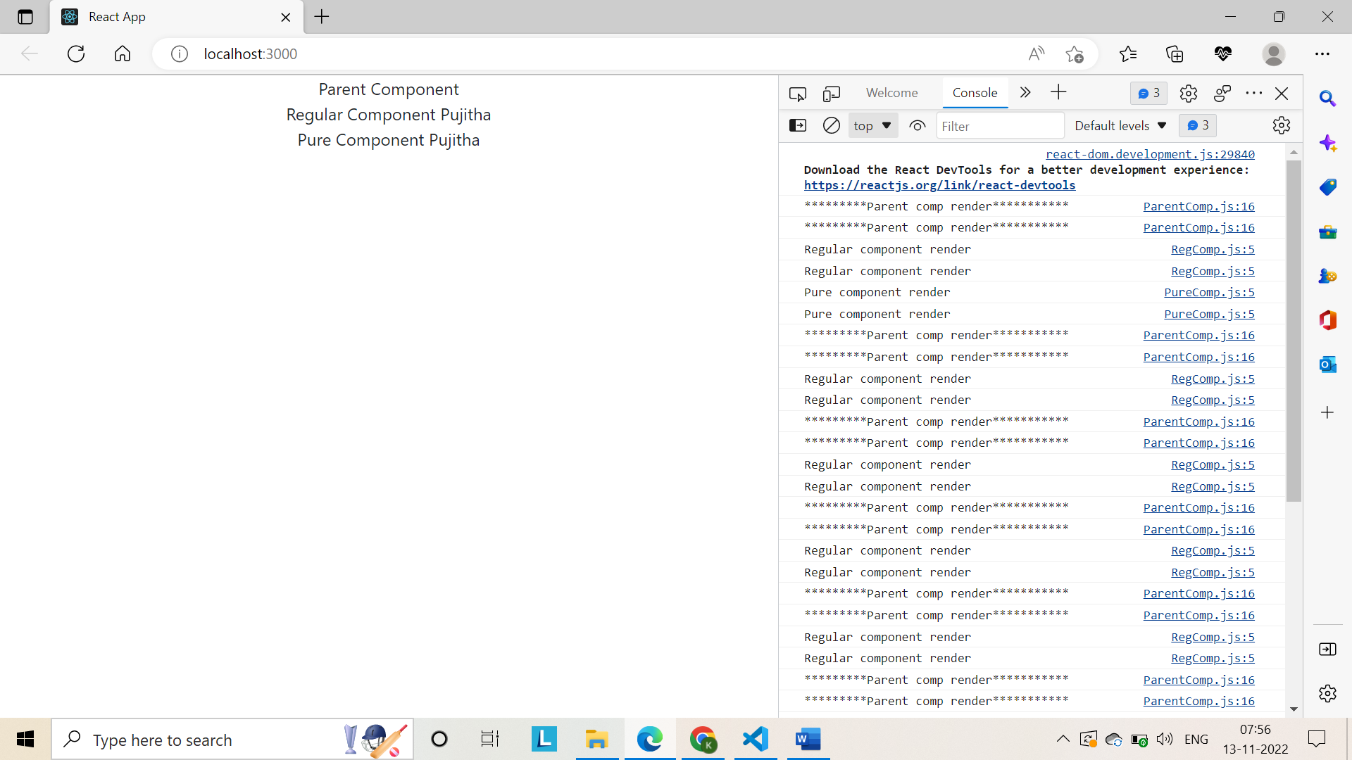

If parent component extends pure component then it re-renders only one time:

import React, { PureComponent } from 'react'

import PureComp from './PureComp'

import RegComp from './RegComp'

export class ParentComp extends PureComponent {

    constructor(props){

        super(props)

        this.state={name:"Pujitha"}

    }

    componentDidMount(){

        setInterval(()=>{

         this.setState({name:"Pujitha"})

        },2000)

    }

  render() {

    console.log('*********Parent comp render***********')

    return (

      <div>

        Parent Component

        <RegComp name={this.state.name}/>

        <PureComp name={this.state.name}/>

      </div>

    )

  }

}

export default ParentComp

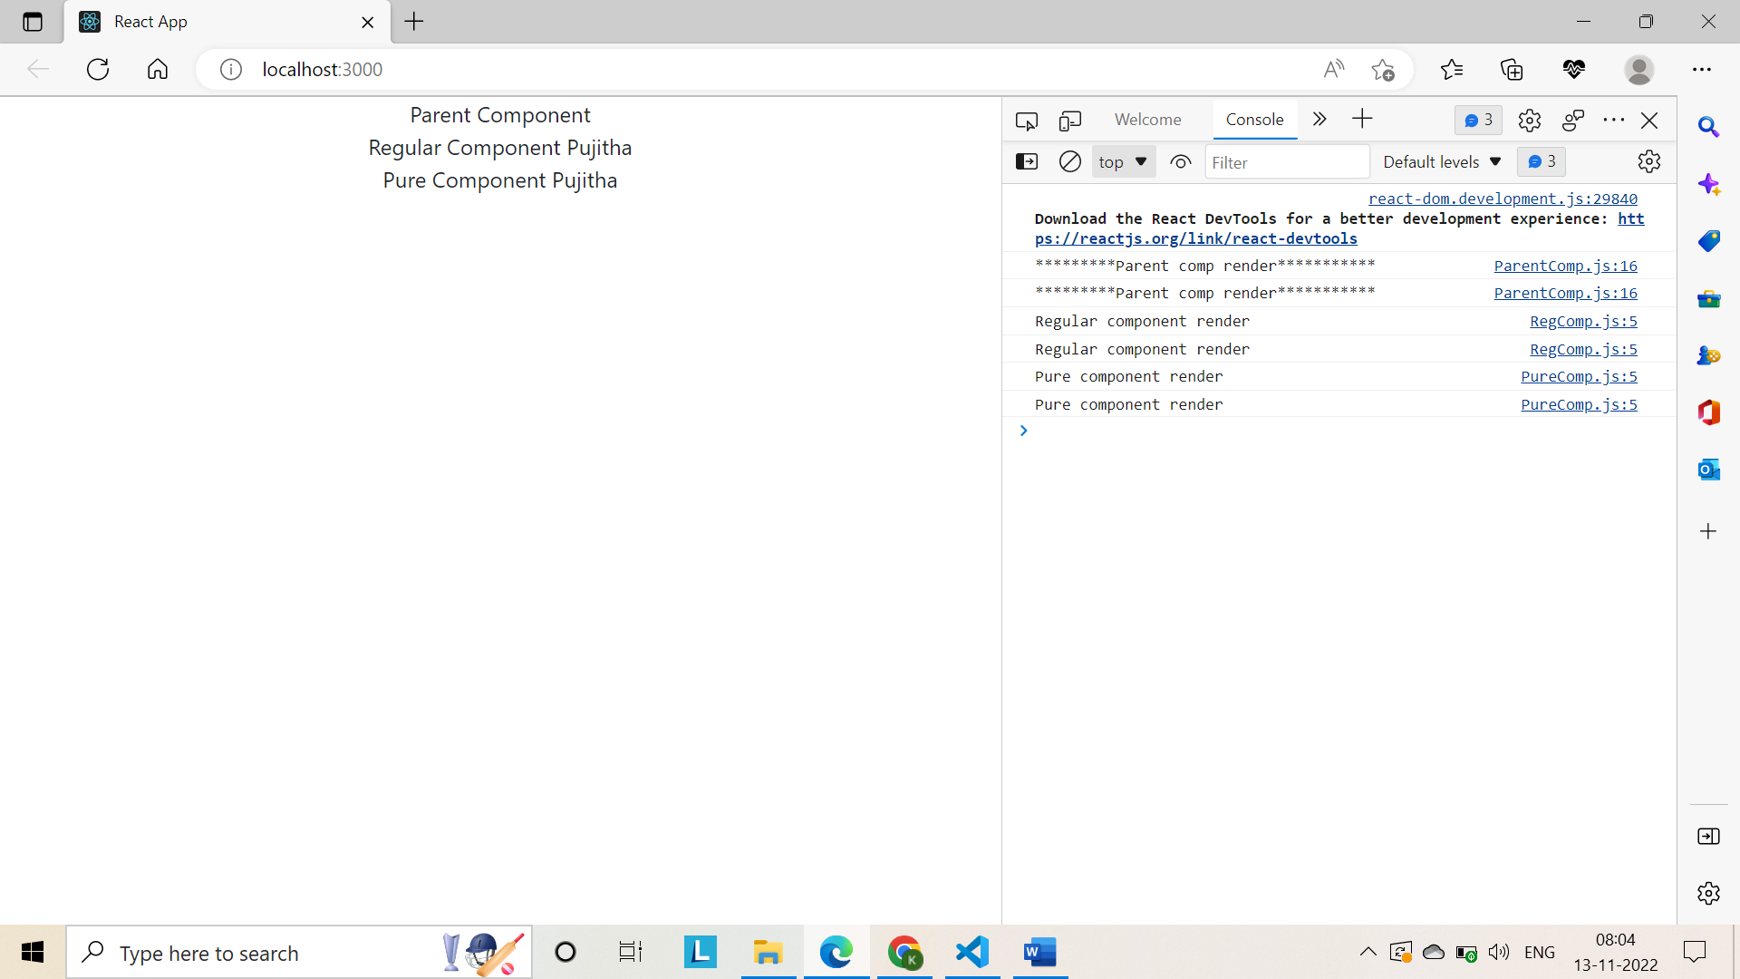

If parent doesn’t re-render the children also doesn’t re-render.

Why use pure components?

Pure components by preventing unnecessary renders can give you a performance boost in certain scenarios.

You should not mutate object, props or state.

In React, we can create a component by extending the PureComponent class.

A Pure Component implements the shouldComponentUpdate lifecycle method by performing a shallow comparison on the props and state of the component.

If there is no difference, the component is not re-rendered thereby providing a performance boost.

It is a good idea to ensure that all the children components are also pure to avoid unexpected behaviour.

Never mutate the state. Always return a new object that reflects the new state.

This concept work with only class components only but not with functional components.

**Memos:**

What pure components does to class components memo is to functional components.

Memocomp.js:

import React from 'react'

function MemoComp({name}) {

    console.log('Rendering Memo Component')

  return (

    <div>

      {name}

    </div>

  )

}

export default React.memo(MemoComp)

ParentComp.js:

import React, { Component } from 'react'

import PureComp from './PureComp'

import RegComp from './RegComp'

import MemoComp from './MemoComp'

export class ParentComp extends Component {

    constructor(props){

        super(props)

        this.state={name:"Pujitha"}

    }

    componentDidMount(){

        setInterval(()=>{

         this.setState({name:"Pujitha"})

        },2000)

    }

  render() {

    console.log('*********Parent comp render***********')

    return (

      <div>

        Parent Component

        <MemoComp name={this.state.name}/>

        {/* <RegComp name={this.state.name}/>

        <PureComp name={this.state.name}/> */}

      </div>

    )

  }

}

export default ParentComp

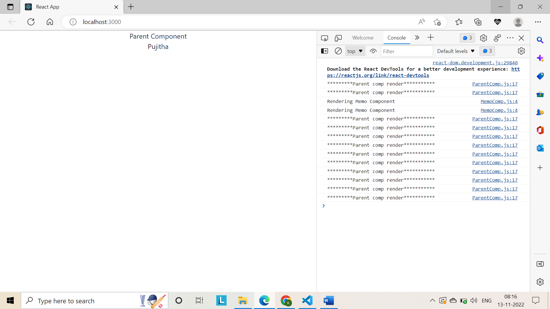

**Refs:**

1. Using create ref method:

import React, { Component } from 'react'

class RefsDemo extends Component {

    constructor(props){

        super(props)

        this.inputRef=React.createRef()

    }

    componentDidMount(){

        this.inputRef.current.focus()

        console.log(this.inputRef)

    }

    clickHandler=()=>{

        alert(this.inputRef.current.value)

    }

  render() {

    return (

      <div>

        <input type="text" ref={this.inputRef}/>

        <button onClick={this.clickHandler}>Click</button>

      </div>

    )

  }

}

export default RefsDemo

1. Callback refs method:

Createref and create property and assign value of null

We create a method that refers DOM element

Attach cbRef to the input element

import React, { Component } from 'react'

class RefsDemo extends Component {

    constructor(props){

        super(props)

        this.inputRef=React.createRef()

        this.cbRef=null

        this.setCbRef=element=>{this.cbRef=element}

    }

    componentDidMount(){

        if(this.cbRef){

            this.cbRef.focus()

        }

        // this.inputRef.current.focus()

        // console.log(this.inputRef)

    }

    clickHandler=()=>{

        alert(this.inputRef.current.value)

    }

  render() {

    return (

      <div>

        <input type="text" ref={this.inputRef}/>

        <input type="text" ref={this.setCbRef}/>

        <button onClick={this.clickHandler}>Click</button>

      </div>

    )

  }

}

export default RefsDemo

with createRef approach you create a reference using react.createRef

with CallbackRef approach you first create a property and then create a method that assigns the property with a DOM element passed as a parameter.

createRef approach we attach the reference to an element using the ref prop and assigning the property.

In callbackref approach we attach the ref to an element using the method that in turn assigns the element to the property.

In callbackref it can be accessed directly using this.cbRef.focus() but in createRef we use this.inputRef.current.focus()

**Refs with class components:**

When we click focus input button in the parent component, the input element in the child component should receive the focus and we achieve that using refs on the input component.

1. In parent component we create a ref using create ref method.

FocusInput.js:

import React, { Component } from 'react'

import Input from './Input'

class FocusInput extends Component {

    constructor(props) {

      super(props)

      this.componentRef = React.createRef()

      }

      clickHandler=()=>{

        this.componentRef.current.focusInput()

      }

    render() {

    return (

      <div>

        <Input ref={this.componentRef}/>

        <button onClick={this.clickHandler}>Focus Input</button>

      </div>

    )

  }

}

export default FocusInput

Input.js:

import React, { Component } from 'react'

class Input extends Component {

    constructor(props){

        super(props)

        this.inputRef=React.createRef()

        }

        focusInput(){

            this.inputRef.current.focus()

        }

  render() {

    return (

      <div>

        <input type="text" ref={this.inputRef}/>

      </div>

    )

  }

}

export default Input

**Forwarding Refs:**

We use forwarding refs’ technique to allow the parent component to directly reference the native input element.

1. Create a ref in the parent component
2. Arrow function is passed as a parameter to forward ref method in child component.
3. Every functional component receives props as a parameter but when a component is passed as a parameter to the create ref method it receives ref attribute as its second parameter.

You can use this.ref parameter and pass it as a value to the ref attribute on the native input element so on the input element ref attribute and assign the value of the ref parameter.

This ref parameter will point the value from the parent component i.e; ref is being forwarded from the parent component to the native input element.

Finally, create a reference in the parent component and attach it to the child component instance.

The child component sees that ref and tells the parent it is not native input element and child component takes it and attaches it to the native input element.

Now parent component can directly access this input element using this.ref variable.current

Child element is basically forwarding ref={ref}.

import React from 'react'

// function FRInput() {

//   return (

//     <div>

//       <input type="text"/>

//     </div>

//   )

// }

const FRInput = React.forwardRef((props, ref) =>{

    return(

        <div>

            <input type="text" ref={ref}/>

        </div>

    )

})

export default FRInput

FRParent.js:

import React, { Component } from 'react'

import FRInput from './FRInput'

export class FRParentInput extends Component {

    constructor(props) {

      super(props)

      this.inputRef=React.createRef()

    }

    clickHandler=()=>{

        this.inputRef.current.focus()//it points to native input element and not input child component instance.

    }

  render() {

    return (

      <div>

        <FRInput ref={this.inputRef}/>

        <button onClick={this.clickHandler}>Focus Input</button>

      </div>

    )

  }

}

export default FRParentInput

**Portals:**

Portals provide a way to render children into a dom node that exists outside the dom hierarchy of the parent component.

Portal provide is the ability to break out of this DOM tree.

PortalDemo.js:

import React from 'react'

import ReactDOM from 'react-dom'

function PortalDemo() {

  return ReactDOM.createPortal(

    <h1>

      Portals demo

    </h1>,

    document.getElementById('portal-root')

  )

}

export default PortalDemo

why we need portals?

**Error Boundary:**

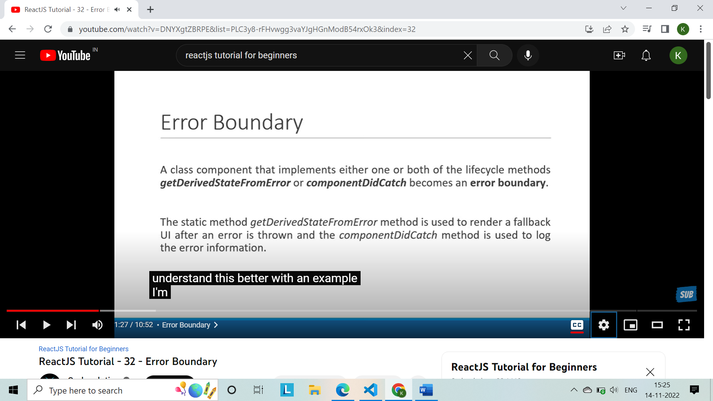

**Render props:**

Another approach well suited for sharing functionality between react components is render props.

HoverCountTwo.js:

import React, { Component } from 'react'

class HoverCounterTwo extends Component {

    constructor(props) {

      super(props)

      this.state = {

         count:0

      }

    }

    incrementCount=()=>{

        this.setState(prevState=>{

            return {count:prevState.count+1}

        })

    }

  render() {

    const {count}=this.state

    return (

        <h2 onMouseOver ={this.incrementCount}>Hovered {count} times </h2>

    )

  }

}

export default HoverCounterTwo

ClickCountertwo.js:

import React, { Component } from 'react'

class ClickCounterTwo extends Component {

  constructor(props) {

    super(props)

    this.state = {

       count:0

    }

  }

  incrementCount=()=>{

    this.setState(prevState=>{

        return {count:prevState.count+1}

    })

  }

    render() {

    const {count}=this.state

    return (

      <div>

        <button onClick={this.incrementCount}>Clicked {count} times</button>

      </div>

    )

  }

}

export default ClickCounterTwo

1. Passing string as prop:

class App extends Component{

  render(){

    return(

     <div className="App">

      <User name="Pujitha"/>

import React, { Component } from 'react'

User.js:

class User extends Component {

  render() {

    return (

      <div>

        {this.props.name}

      </div>

    )

  }

}

export default User

1. Instead of passing string we can pass a function that returns string as return type.

Main: app.js:

class App extends Component{

  render(){

    return(

     <div className="App">

      <User name= {()=>"Pujitha"}/>

User.js:

import React, { Component } from 'react'

class User extends Component {

  render() {

    return (

      <div>

        {this.props.name()}

      </div>

    )

  }

}

export default User

1. To have parameter to the function in the main prop:

class App extends Component{

  render(){

    return(

     <div className="App">

      <User name= {(isLoggedIn)=>isLoggedIn?"Pujitha":"Guest"}/>

User.js:

import React, { Component } from 'react'

class User extends Component {

  render() {

    return (

      <div>

        {this.props.name(false)}

      </div>

    )

  }

}

export default User

1. In app component rename name prop to render

class App extends Component{

  render(){

    return(

     <div className="App">

      <User render= {(isLoggedIn)=>isLoggedIn?"Pujitha":"Guest"}/>

User.js:

import React, { Component } from 'react'

class User extends Component {

  render() {

    return (

      <div>

        {this.props.render(false)}

      </div>

    )

  }

}

export default User

it is possible to use prop whose value is a function to control what is actually rendered by a component

Render props:

The term “render prop” refers to a technique for **sharing code** between React Components using a **prop whose value is a function.**